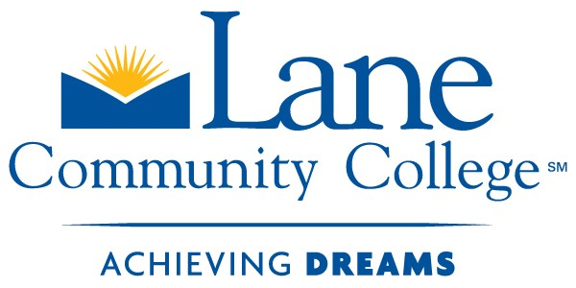 | High School Connections
 | College Now ● RTEC Expanded Options ● Pathways
 | Lane community College
 | 4000 East 30th Ave Eugene, OR 97405
 | Phone: 541.463.5521 Fax: 541.463.4734

First Name | Last Name | Submission Date
First Name | Last Name | Submission Date
High School | Phone Number | Email
High School | Phone Number | Email
Address
Address

Culinary Arts and Hospitality Management classes that articulated will be evaluated on the following criteria:
HRTM 105 Restaurant Operations (3 Credits):
- Professional Qualifications of the Instructor/Teacher
  - Professional Certifications
  - Education
- Class content to include:
  - Subjects (i.e. Recipe Conversions, Cooking Fundamentals, and Safety/Sanitation)
  - Class Syllabi, Content Materials List, and Grading Rubrics

Professional Qualifications of the Instructor/Teacher
☐ | Culinary Arts AAS or BA, BS, BFA
-and-
☐ | 5 years’ experience in food service or (ACF Certification at or above CCC)
-or-
☐ | 10 years’ experience and demonstrated culinary skills or (ACF Certification at or above CEC)

Documentation Checklist

Personal
☐ | Resume
☐ | Transcripts
☐ | Certifications
Curriculum Materials
☐ | Syllabus
☐ | Weekly Schedule (Include you Menus)
☐ | Textbook List

Class content to include:

Course Competencies(HRTM105): |  | Lane CC |  |  | Your Class
 |  | Lecture | Lab |  | Lecture | Lab
Introduction to Hospitality
Demonstrate the general rules of table settings and service. |  | 1.5 | 0
Describe American, French, and Russian table service. |  | 1.5 | 0
Discuss the service methods such as banquets, buffets, catering, and a la carte. |  | 3 | 0
Describe the functions of dining service personnel. |  | 2 | 0
Discuss the procedures for processing guest checks using current technology. |  | 1.5 | 0
Discuss sales techniques for service personnel, including menu knowledge and suggestive selling. |  | 2 | 0
Identify all local, state, and federal laws pertaining to the purchase and service of alcoholic beverages. |  | 1.5 | 0
Discuss the basic production process for distilled spirits, liquors, beer and brandies. |  | 1.5 | 0
Distinguish wines by grape and/or other variety, country, growing region, and production process. |  | 1.5 | 0
Evaluate the relationship of beverages to food. |  | 3 | 0
Identify and discuss the presentation and service of alcoholic and non-alcoholic beverages, including coffee and tea. |  | 1.5 | 0
Identify equipment and glassware used for beverage preparation and service. |  | 1.5 | 0
Discuss opening and closing procedures of a beverage operation. |  | 1.5 | 0
Discuss the fundamentals and importance of responsible beverage service. |  | 1.5 | 0
Identify levels of intoxication and methods to control excessive consumption by guests. |  | 1.5 | 0
Discuss Dram Shop Act and liquor law liability. |  | 1.5 | 0
Describe the various cuisines and contributions of leading culinarians. |  | 3 | 0
Evaluate career opportunities through participation in field trips and guest speakers in class. |  | 3 | 0
Discuss/evaluate industry trends as they relate to career opportunities and the future of the industry. |  | 1.5 | 0
Discuss and evaluate industry trade periodicals. |  | 1.5 | 0

