Diversity Council White Paper
By Mark Harris
B.A.S.E. Griot Pro-Tempore

This Diversity Council White Paper’s purpose is to document the genesis of diversity / equity efforts, at Lane Community College. Certain features of Diversity Council, unique in the LCC Governance system, date back to both Diversity Team, as well as certain community led efforts initiated, by students, community members, staff, as well as managers, administrators, and faculty at the college.
Lane Community College, demonstrably the flagship community college in Oregon, is situated in Eugene, Oregon, a redlined, sundown town. People of color were not allowed to live in the city limits, nor be on the street after dark. Oregon was founded to deny entry to Black American citizens of the United States, while allowing White foreigners the same rights as white Oregonians.
In one sense then, staff at Lane have always played a part in the Civil Rights struggle of the community, state, and nation, as well as being home to those who resist such struggle for what they perceive as a status quo.
Various programs like the Women’s Center, Multicultural Center, Ethnic Studies, Affirmative Action, could be considered organizational nexuses around which concerted concrete action can form and be implemented. Actions like creating a position like diversity coordinator, or Chief Diversity Officer, a Longhouse, an EAP responsive to racial and sexual harassment issues, as well as recovery issues, or referral to treatment; curriculum, special programs like Rites of Passage.
Diversity Team then was action / implementation oriented, because the jobs of people composing it, were to do those specific innovations in compliance with the law, or best practices where the law was deficient, as it often was. Diversity Council was not implementation, it policy review and oversight oriented. Diversity Team was an action / task oriented coalition with up to 34+ members representing Affirmative Action, Americans with Disability Act, Socioeconomic Status, Gender, Religion, and others. Diversity Team: Multicultural Center, Women’s Center, Disability Services, Native American program, Multicultural Center, Substance Abuse Prevention, as organizational nexuses, because they are specifically staffed by Affirmative Action protected class employees. Affirmative Action as a matter of organizational practice collects, analyzes data, to assure compliance. Substance Abuse Prevention also attempted to collect data, and applies evidence based, or community defined evidence interventions and practices, to ensure organizational compliance. We often collaborated because of the history of illegal discrimination in hiring, discrimination against recovering clean and sober productive job applicants, of color, in favor of demonstrably intoxicated on the job, incumbents. The Federal government believed at the time, that a diverse clean and sober workplace was a optimal workforce for recovering populations and diverse populations. A collaboration between the Women’s Center, Multicultural Center, Substance Abuse Prevention, helped recreate Ethnic Studies, (Then Interdisciplinary Studies including Women’s Studies) which after being created, staffed, with increasing enrollment, in the early 70’s, was destroyed by the Lane Board of Education (BOE). The BOE, like any part of Lane could be a force for progress, or a force impeding progress. Ethnic Studies would be recreated in the late 90’s, but that of course meant diverse hiring, in a department which historically (as measured by hiring patterns and climate) was hostile to ethnic minorities.
Lane’s first and only African-American President, implemented a policy of utilizing national searches for faculty, management, and administrative searches. This actually had been the law, since President Kennedy’s original Executive Order in 1963. Colleges and Universities defined their local hiring areas for administrators, management, and faculty as the nation. Where implemented, this had the potential for bringing talent to the college, with a national, if not international perspective. Where resisted, as became the organizational culture in many departments (7 of which are named in published forms of the BASE files), which over the years have evidenced harassment complaints, hostile work environments, and low protected class hiring and retention rates. While not always welcomed, these nexuses represented perspectives did move the college forward, where they were retained.
In 1990, two faculty of color, proposed mandatory cultural competency training for all staff, in line with other efforts being carried out throughout the state, and workplaces in the community.
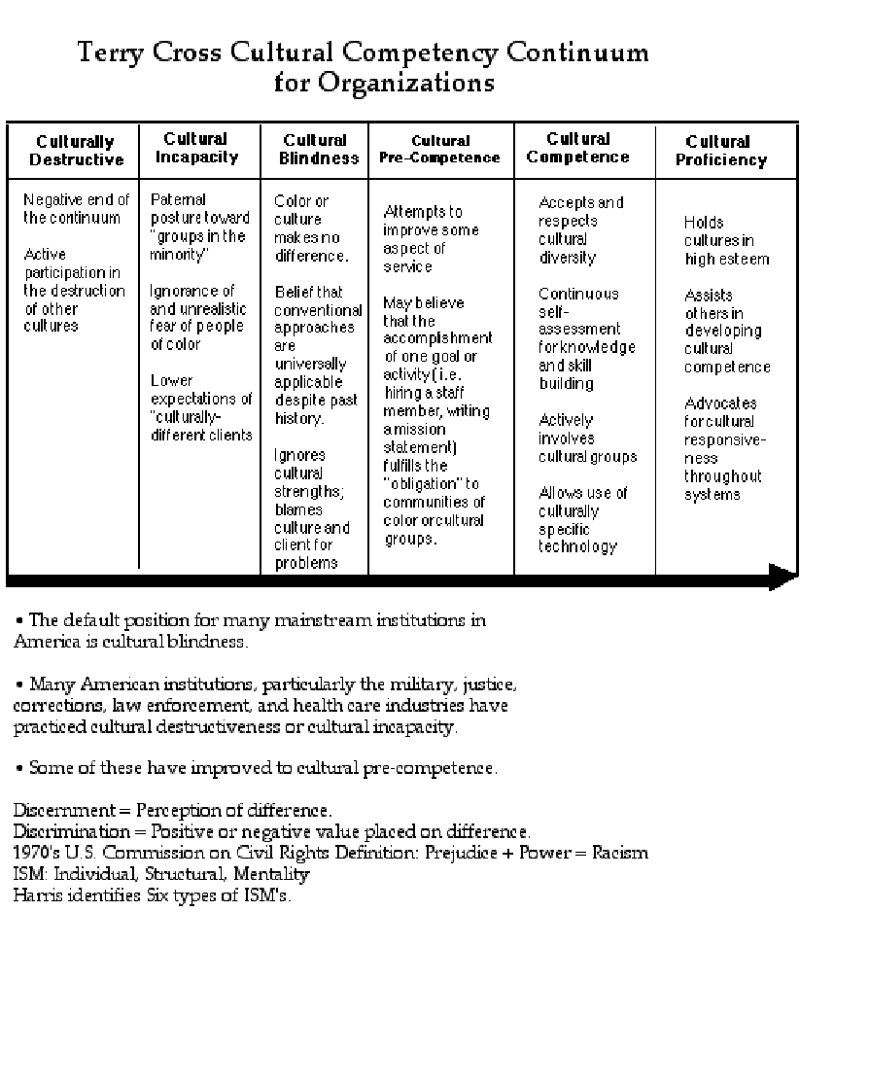
Cultural Competency was a construct developed by Dr. Terry Cross of Portland State. In response to ICWA (Indian Child Welfare Act) Cross, a Native American researcher and faculty, developed an institutional and individual model where institutions and individuals could assess on a six stage continuum, their practices. Cultural Competence, implies active skill, and skill building towards proficiency, particularly where a culture has encountered genocide, multigenerational trauma, and or current systems of patterned discrimination. Its not simply Cultural Awareness, or Literacy, which do not imply active progressive change. For example the State of Oregon, and by extension its institutions, were founded on principles of Cultural Destructiveness. They have evolved generically to the American default setting of Cultural Blindness. Some institutions within Oregon, have adopted or promoted a culturally competent standard of care (Oregon Administrative Rules for Addictions and Mental Health, and SB 555).
Cultural Proficiency beyond Competency, begins when you can articulate and utilize cultural technologies outside of the originating culture, to benefit others from within those cultures, or whose home culture does not have the same beneficial constructs.
Cultural Proficiency, begins not simply with a statement that you hold a culture in high esteem, but that you can know, discover, answer, utilize basic questions about a culture as asked below…what is their Origin Story, what are their culturally appropriate or optimal technologies for healing. How current are they? Do they meet the needs of the people today? How do they need to change, and how would cultural insiders change them? What are the constructs like racial microaggressions, and intersectionality, developed within scientific communities of color, useful in the mainstreatm?
LCC could have departments that were actively culturally destructive, such as a history teacher who taught Slavery improved Black people by raising them up from savagery. But they should remain in their place subservient to whites who are the superior race. “Hispanics don’t work out well in this department”, “If I had a gun, I’d shoot that “N****r” (Said of his then supervisor, by a person who still works here, when he was a probationary employee). LCC could also have departments that chose to hire professionals of color, who also represented class, gender expression, diversity, and on their own offered regular staff training.

I myself had been recruited by the Multicultural Center Coordinator, out of one of those community activist networks.
In 1991 – 1992, two African-American staff members were hired 6 months apart. The Affirmative Action Officer, and the Substance Abuse Prevention Coordinator. We were both charged with Federal compliance within our respective areas and the college was out of compliance in both our areas. Normal hiring patterns at the college were wildly illegal: nepotism, illegal discrimination based on race, gender, gender expression, disability / recovery status, and those were the ones I was aware of because they affected my areas of concern.
Though Affirmative Action was independent of Human Resources, and technically reported to the president, she was not housed in the administration building. Her office, was a closet, housed in the Women’s Center, which was then housed on the second floor of the Center building. She was not given an admin to help her with either the workforce analysis, or any data necessary for the college to get into compliance. She made do with a Work Study student, to assist her with the data collection.
I had similar problems in my work sphere. Professionally I was part of the Substance Abuse Treatment field, that observed from a distance, my predecessor go through a relapse, in place. Obviously he wasn’t accessing his self-care, and no one noticed. He also, was teaching in one of the more demonstrably racially toxic departments, and discouraged clients and students of color from entering the Substance Abuse training program. In addition, staff were coming to campus under the influence, during work hours. Each one would have successive layers of protection, the higher they were in the hierarchy of the college. Not that it was any different in other parts of society. Some sections of Lane, replicated 1950’s Eugene. In one incident a faculty member sexually assaulted a student in his home, while under the influence. While some people thought because it happened off campus, and the woman wasn’t pressing charges, and the faculty went into recovery, that was a “win”. Though some might consider in a win, I didn’t see it that way, and Title 9, personnel of today would not either. Another symptom.
A potential job applicant of color, who had been in recovery for multiple decades, was refused a job, in a department where substance abuse on the job was tolerated, in multiple people, on multiple occasions. It goes without saying, but to be clear, a minority job applicant in recovery was refused employment, while known active addicts alcoholics who also stole college property, were hired, tolerated, and retained. This remains a consistent pattern to the present day.
Despite laws being in place to allow and enable policies, like diverse, productive, sober hiring, retention, and recruitment, that was not the rule at Lane. Many members of Diversity Team, were charged with creating policy where none existed, Diversity Team had an implementation function, and had suggested creating a Diversity Coordinator / Chief Diversity Officer staff position, originally conceived as a cabinet level position, but was implemented at the classified level until the creation of Diversity Council. Additionally, hiring training for search committees to ensure compliance with the law (Originally conceived for all committee members, in practice only search committee chairs). Where hiring patterns in many departments, was consistently illegal, and discriminatory, some attempts were implemented to hire diversely, and met with resistance. To illustrate, the Affirmative Action Officer made a presentation to the Board of Education, on a recent faculty hiring process — mine. For 44 positions created by retirements and other vacancies, there were over 1400 applications from a national pool. Over 160 of those were minorities.
If Lane’s hiring processes were proportionate to what was available in the local hiring area, in this case the nation, you might expect that roughly 10% of the pool might be considered and hired. In other words 4 of the 44. They hired one minority candidate, me. Is it possible that only 1 minority out of 160 plus was qualified? So, the solution was not only implementing consistent hiring policies and procedures, but targeted goals. The Affirmative Action officer had announced a goal of 25 Black Faculty based on what was available in the national professoriate. Pejoratively these are what are known as quota’s, that is the targets of actual people working in a particular job class, even with assuming discrimination. Lane has even now, never had more than 7 full time, and 15 total including part-time and online.
Also training for managers to identify and refer employees to substance use treatment. Selecting an EAP that not only responded to substance abuse, but also responded to racial and sexual harassment. For hiring, managers are now trained by Affirmative Action, committees are not. Though originally in D-Team we wanted every member of a committee to be trained in AA not just the manager or committee chair. As a general rule, regardless of which way the political winds blow in the country, doing the right thing, that’s demonstrable the right thing, should remain the standard practice. As the Affirmative Action officer once told me describing her rationale for following Affirmative Action: “It’s a weak remedy to a persistent problem. But people died to have Affirmative Action, just like they died for voting rights, and equal access. They will not have died in vain on my watch”.
On multiple fronts then, the newly constituted Diversity Team, in addition to being a source of policy discussion, creation, and implementation, also became a safe space for diverse staff. Membership was open and inclusive, and an effort was made to include not only protected classes, women, minorities, disabled, veterans, but those who had no legal protection like LGBTQIIA, and others. The bargaining units were invited to participate, and consistently declined. A place for policy implementation, as well as safe space was an expectation that that carried over when Diversity Team was disbanded. Diversity Council was created — without any member of Diversity Team’s inclusion. (Imagine creating a Diversity Council, without any Black employees on it?) The members by position, were included on Diversity Council, to not only allow all Diversity Team members entry and voting input, but to allow a mechanism for inclusive expansion, and retention on the council. Members by position participated in what I refer to as Longhouse Rules of Order. A feature of indigenous democracies, is that council members served for as long as they wished, they could choose not to participate, but there was no process for removal from council. In Longhouse Rules of Order no one saw the need to remove anyone else because we needed the input of “All My Relations”. Save possibly for egregious malfeasance or breach of protocol, which had never happened in Diversity Team, and didn’t happen in Diversity Council, until what I refer to as The Incursion, January 15, 2014. Diversity Council had followed a process laid down by Diversity Team which was any community member could bring issues of concern, and feel safe enough to speak openly and frankly, but respectfully. Minority staff had expressed in public to the board of education, that their respective bargaining units did not protect them, from their own members, and others. Unions have what is referred to as a Duty of Fair Representation. Since predominately white unions fail to proactively act to protect their members of color for example, employees may act on their own behalf to form their own interest group along identity lines. The state and national levels of OEA and NEA have their Minority Leadership groups, LCCEA could follow suit, or encourage participation, or address issues in a culturally competent manner. A statement had been made to the board by the co-chair of Diversity council, regarding the inaction of her bargaining unit, to diversity issues. She made it clear she was not speaking in her Diversity Co-Chair role, or her role as an employee, but as a private citizen community member. This was nothing new, in 1998, I had made a similar statement to the BOE, in the creation of BASE (Black American Staff / Faculty Employees). Such Strategic Employee Affinity Groups are a common feature in many workplaces. Only the African-Americans attempted to organize such a group, others ethnic groups have greater numbers. The need for such groups became apparent when on Martin Luther King’s birthday, three white men attempted to remove the co-chair. She pointed out, while she was serving as her union’s designated representative, she was also a member by position, by virtue of being part of Diversity Team. She was remaining on the council, having been elected unanimously for several years running. She stated that she couldn’t be removed, but did voluntarily step down, while the membership question was settled (Actually never in doubt except in the minds of the aforementioned white males). She handing over leadership of Diversity Council to the Chief Diversity Officer, co-chair by Charter. In fact, several of us in the room were at the original meeting of Diversity Council, where all members of D-Team, were included permanently. None of the white men, were present at that original D-Council meeting. They chose to disbelieve their minority members who were present at the original meeting. Proving the allegations made at the BOE: The bargaining units are not protecting their members of color, from harassment by white members. In fact, this was seen as an attack questioning the legitimacy of all members by position, majority people of color. The white men wanted to have minutes from the meeting in question read. Minutes, were produced for the meeting in question, including the quote “Now everybody in the room is on Diversity Council” spoken by this writer. One could see this as retaliation for speaking an uncomfortable truth, for white men, or a statement of fact for persons of color in a historically racially hostile environment. In Civil Rights struggle, which Diffusion of Innovation research suggests, there will always be Early Adopters, as well as pockets of resistance, this is true of health practices, as well as technology. After the Incursion failed to remove people of color from Diversity Council, in the next meeting in Black History Month, the same three tried to introduce a motion supporting term limits, which no other governance council had. While to their slight credit, the bargaining units had supported mandatory cultural competency training in response to use of the N-Word, a position that was reversed in subsequent Council meetings by the faculty president. Who was the sole dissenting vote (Voting against 5 faculty on D-Council) to the Diversity Council initiative supporting mandatory cultural competency training, an initiative where Lane faculty of color continuously maintained a collaborative leadership role. Pockets of innovation remain, operating independent of Council, and the Bargaining Units. Some of these, have left council to implement work in their own.
Since the students, bargaining units, management, and administration were not required to have such inclusion on their own, there was no mechanism to ensure skilled inclusion beyond good faith. Participation is voluntary, and one is presumed to be interested. Unlike members by position who were content experts deemed necessary for the council to do its work, the “Noah’s Ark United Nations 2 by 2 of every diverse food group” nature of the structure, made for some continuity of purpose issues.
Until the Incursion, good faith had basically been displayed, but there was no method to continuity of skill and competency, from appointee to appointee
Diversity Council had set as its purpose, creation, policy and procedure review, but not necessarily implementation. Diversity Team, on the other hand, was composed of members who initiated, innovated, implemented, actions, programming, which had policy implication. For example creating a Longhouse came about because in an attempt to create a Native American Recovery group, where it is customary to burn medicine (cedar, sage, sweetgrass), public safety was called because “someone was smoking pot” in the Center building basement. (Like the drug counselor is going to smoke weed, at 12 o’clock on a sunny day in a basement with a group of people…) Even with advance notice, a fire extinguisher, posted signs, we gave up. When the Native American Student coordinator (A member and performer in the Native American Dance Troupe) wanted to have Native Dance classes to support Pow-Wow activities, as a cultural promotion and prevention activity, he was denied space in the dance studios. Native American dance, is a spiritual activity, not a performance, drum songs are prayers, not performances. Clearly a Longhouse needed to be built.
If there are policies and procedures driven by case law, and Supreme Court rulings, where the law hasn’t caught up to certain sets of knowledge, skills, and abilities, the college could still support innovative action that constituted support.
For example racial harassment forbids certain language like the N-Word. Use of the N-Word is not protected speech and can result in disciplinary action. In fact, the reason that Lane has a zero-tolerance policy is because of the use of the N-Word in the workplace. In at least 4 incidents of the use of the N-Word in the workplace, (One coupled with a gun threat), termination has not occurred, even when clearly warranted The users of the word where known, have been retained, very little to no institutional support has been applied to the targets. For the phenomenon of racial microaggressions, which occur far more frequently, result in increased health claims, and stress related diseases. There is little institutional acknowledgement or support, let alone understanding of what actions to take in support of staff who experience them.
When a recent “free speech incursion” occurred on campus, with its disturbing imagery, and message memes, part of the response of an educational institution is to be prepared with an educational response, and (from my point of view) a culturally competent therapeutic response, to the psychological and emotional disturbance. It is predictive that the memes of white supremacy would be mixed with a white genocide anti-abortion message (always a theme with them) mixed with an appropriated Black Lives Matter / All Lives Matter message, combined with images of historical genocides committed by white supremacists, (as if the group weren’t itself). I know how I would respond, and can indeed create a policy praxis plan going forward.

With a philosophical or tactical shift from the use of the term, Diversity, to Equity, and Inclusion, the Equity Lens may mean a shift in terminology, but will it also mean a dilution of effective and evolutionary policy implementation?
The CDO position was created to take a leadership role, but the tasks are too large for one person. With the Equity Lens, care must be taken to illuminate both the structures which impede innovation, and the progressive places, programs, and persons, who work to implement change, or preserve necessary traditions.

