**Evergreen Valley College**

**English Department**

**Program Review**

**Spring 2011**



**Prepared by the**

**Evergreen Valley College English Department**

**Final Compilation by Sterling Warner**

**Submitted May 2, 2011**

**Evergreen Valley College**

**Program Review Self-Study Document Criteria**

**04-28-11 final**

In preparing this Program Review, keep the college mission, strategic plan CTAs in mind as a reminder that Program Review is to ensure that all programs are aligned with the institutional mission.

**Evergreen Valley College’s Mission**: With equity, opportunity and social justice as our guiding principles, Evergreen Valley College’s mission is to empower and prepare students from diverse backgrounds to succeed academically, and to be civically responsible global citizens.

**DEPARTMENT/PROGRAM NAME: English/English Composition/Literature**

**LAST REVIEW:……….** 2000 (Prepared by Sterling Warner; Rita Karlsten: Dean)

**CURRENT YEAR:……**Final Compilation Prepared by Sterling Warmer**……**2011

**AREA DEAN:……………………………………………………………**Keith Aytch

**SUMMARY OF THE DEPARTMENT/PROGRAM**

**Provide a brief summary of the department/program including brief history (impetus for department/program initiation if applicable, years of existence, progress made or not made over time, any other major factors that affected the program and current status)**

Most of the composition and literature classes taught through the English Department at Evergreen Valley College have been around as long as the college itself (1975), offering students and the EVC community members a balanced curriculum ranging from “basic skills” courses to transfer composition, literature, and creative writing classes. Until the present day, the English Department offers more section of a single class—English 1A—than any other course on campus, and yet it still cannot keep up with the public demand for more of them.

Evergreen Valley College underwent a major reorganization in 1993, and Center Coordinators were replaced by 1) discipline chairs, and ultimately 2) deans. Currently, the Language Arts Division, of which English is a part, has a Full-time dean, supported by administrative assistants. To serve students at Evergreen Valley College, the department experimented with several models of delivery particularly geared towards enhancing reading, writing, and critical thinking skills at the developmental level.

In 1995, English Faculty continued to respond to student interests by creating an English AA at EVC. Since its debut, the English AA track has been an unmitigated achievement; it promotes equity and attracts diverse students across the campus, presenting them with equal opportunities to pursue carreer objectives with an emphasis in written communication and literature. In turn, this prepares them for both transfer and terminal degrees. Finally, due to their critical, creative, and analytical skills, students with English AAs have become a hot commodity in the work force—especially leadership positions—today. One only need Google a few college publications such as inside english (the ECCTYC Journal), TETYC (Two-Year College English Association Journal), Inside Higher Education, The Chronicle of Higher Education, and College English (CCCCs Journal) to locate weekly, monthly, and quarterly articles that testify such information.

All in all, the organizational restructuring enabled instructors to enact “student center” change as part of a bonified English Department in the Language Arts Division. Therein, members gathered together, shared expertise and offered innovative teaching  methodologies to connect with diverse student learning strategies. To preserve a record of English Department accomplishments, updates, policies, planning efforts, and other specific research—the Composition/Literature Curriculum Committee compiled a “living document”: *The Language Arts Continuum: A Handbook of Practices, Procedures, and Studies (Past and Present)*.  The 1992, 1993, 1990, and 2001 hard copy editions of “the continuum” offered counselors and administrators—as well as new full-time and adjunct instructors—a quick, up-to-date resource handbook, accessible to all campus personnel, that chronicled significant studies including: “A Comparison of The Composition Teaching Workload At Evergreen Valley College to Composition Teaching Workloads at Other California Two-Year Colleges”; “The EVC English Program Review (2001)”; CSU/ECCTYC Resolutions; “Report to Board of Trustees: Student Writing, Programs, and Proposals”; ““The History and Future of Language Arts [focus on English] at Evergreen Valley College”; and a historical perspective on the goals, objectives and “Strategic Plans” for the EVC English Department; as well as The most recent versions of important documents/position papers such as landmark paper, “Teaching Writing in the [California] Community College: Implications for English Faculty and Community Colleges” (co-authored and edited by a member of the EVC English Department)—to name a few. *The Language Arts Continuum: A Handbook of Practices and Procedures* still offers instructors, counselors, and administrators an in depth record of policies and procedures championed by the English Council of California Two-Year Colleges, the Two-Year College English Association, the National Council of Teachers of English, and the Modern Language Association to name just a few high profile English organizations that provide insight and guidance to college instructors. Forms of the *Continuum* have appeared in many documents since the last hard copy edition.

The English Department faculty further anticipated the need for an easy reference to course outlines, and featured them in the four editions of the “continuum, including: (1) the San Jose/Evergreen District articulated course outlines for English 1A and English 1B; (2) Evergreen Valley College English Department outlines for English 330 and English 104—outlines that included minimum articulated requirements for each course; (3) various articulated literature and creative writing course outlines (4) San Jose State University English Department outlines for English 1A and English 1B; and (5) the University of California Berkeley Subject B course outline.

For well over a decade, the faculty driven “continuum” has provided full-time and adjunct English Professors with three sample greensheets written by English peers for English 330, English 104, English 1A, and English 1B; as well as two sample greensheets for English 1C, as well as a few others from varied courses. Many of the greensheets provide readings and representative assignments.

To date, the EVC English Department offers its students “cutting edge” learning methods consistent with the “best teaching practices” used by its instructors. The EVC English Department’s commitment to excellence has become increasingly more complex and challenging due to the growing heterogeneity of its student population, the increasing demand for developmental instruction, and the expanding skills requirements in the workplace. Undaunted, however, English faculty members modify curriculum, expand their higher education partnerships, and work with other English professionals in the field on the local, state, and national level to remain abreast of effective teaching practices. Without question, the acquisition of writing—as well as critical thinking—skills has been and will continue to be fundamental to the persistence and success of EVC’s students, and English faculty do everything possible inside and outside of the traditional classroom to assist them achieve their academic and career goals.

## PART A: Overview of Program

1. **Identify EVC’s CTA for this year.**

(1) Student-Centered: We provide access to quality and efficient programs and services to ensure student success. Areas of focus are:

a. Access

b. Curriculum and Program Development

c. Student Service Offerings (offer multiple methods of delivery)

(2) Community Engagement: We create a trusting environment where everyone is valued and empowered. Areas of focus are:

a. Visibility

b. Strategic Partnerships

c. College in the Community

(3) Organizational Transformation: We will transform the college image and enhance partnerships with community, business and educational institutions. Areas of focus are:

a. Community Building

b. Employee Development (sabbaticals, conferences, professionalism)

c. Transparent Infrastructure

**2. Identify your program/department’s CTA for this year.**

Outside of management, the English Department—like the majority of rest of the Evergreen Valley College campus community—has not developed new CTAs since 2008. Nonetheless, Students always have been first and foremost among faculty values, proposals, pedagogy, and advocacy.

* The English Department at Evergreen Valley College embraced the concept of CTAs—*Commitment to Action*—long before somebody coined the term. We assert our CTAs day by day and year by year; we live them.
* National TYCA’s (Two-Year Community College English Association) recognition for its innovative/best teaching practices testifies the fact that, since its last program review in 2000, the faculty and staff at Evergreen Valley College’s English Department have remained dedicated to providing instruction of the highest quality in the teaching of composition (all levels), literature, and critical thinking.
* Prior to CTAs and SLOs becoming buzz words in education, the EVC English Department managed to establish and has maintained uniformly enforced exit standards throughout composition courses and corresponding ESL composition classes (English 330 and ESL 312; English 104 and ESL 91; English 1A and English 1A with ESL focus.)

**(Question: Who is responsible for bringing yearly development of CTAs to the faculty’s attention? If administration, what consistent schedule does it intend to put in place to assure that this occurs**?) We always share information about the profession in department and division meetings, and this has been done for decades—long before “CTAs” became a buzz.

1. **Describe how your program/department met the overall CTA of the College.**

### A. Student Centered CTAs met:

The English Department in particular has been and continues to be:Student Centered. It works directly with students, support services, counseling, special programs, and community outreach projects, increasing its visibility beyond the traditional classroom.

* English Faculty members serve/served as advisors for student clubs, including: The EVC Authors’ Guild, The Desi Club, The English Majors/Language Lover’s Club, ESA (Enlace Student Association), TheEVC Newspaper Club, Phi Theta Kappa (the national honor’s society), Students for Justice, and VSA (the Vietnamese Student Association).
* English Faculty members participate in EVC’s Club Rush.
* English Faculty members participate in EVC Kicks It Outside event.
* English Faculty members work with and participate in Honors Program.
* English Faculty members work with and participate in FasTrack Program.
* English Faculty members work with and participate in the Affirm Program
* English Faculty members work with and participated in Aspire Program.
* English Faculty members work with and participate in the Enlace Program
* English Faculty members work, participate, and promote the Learning Communities Program.
* English Faculty members work, participate, and promote the Service Learning Program.
* English Faculty members frequently update department outlines for all English courses.
* English Faculty offer EVC students composition and literature classes featuring multiple methods of delivery, including lecture/discussion, learning communities, online classes, hybrid classrooms, culturally specific sections, and service learning projects.
* English Faculty members developed Student Learning Objectives for all courses in 2005 and refined them at least once since then.
* An English Department member initiated and continues to coordinate a *student/community centered* Authors’ Series at EVC, that feature diverse, high profile speakers—in addition to poets, novelists, fiction and nonfiction writers.
* English Department members participate in and support literary event on campus, including monthly “Open Microphones,” the EVC Authors’ Series, and the Annual EVC Spring Poetry Festival.

### B. Organizational Transformation CTAs:

EVC English Department faculty members have participated in shared governance by serving on campus and district-wide committees, including:

* Academic Faculty Senate Committee
* Communication Across the Curriculum Committee and wrote the final CAC report
* Curriculum Committee
* EVC College Council
* Professional Recognition Committee
* Staff Development Committee
* Standing Committees
* Screening Committees
* Tenure Review Committees

**C. Community Engagement**

Even before the English Program became an officially acknowledged department, its beliefs, values, goals and objectives were “committed to action,” identifying and advocating on going needs and reshaping curriculum to meet the every changing teaching and learning needs at Evergreen Valley College.

* English faculty designed the EVC English AA program in response to student demand.
* Since the last English Department Program Review in 2000, the English faculty, working with peers across the disciplines. have developed and continue to offer basic skills and transfer level learning communities. They also teach courses through our culturally specific programs, assign service learning activities, and work with other special programs on campus.
* English faculty members reach out to the EVC community—as well the San Jose/Evergreen Community College District—endorsing and promoting “faculty driven—student centered” literary events such as The EVC Authors’ Series, EVC Creative Writing Workshops, and the Annual EVC Poetry Festival—as well as other cultural, social, and literary events.
* English faculty members explore new reading/writing pedagogy and apply “best teaching practices,” to their own style of instruction methods.

**Describe areas where your program/department needs improvement to meet the overall CTA of the College. Describe specific plan to achieve this goal.**

* The EVC English Department not only meets but excels in meeting the overall CTA of the college.
* The English Program/Department does not need improvement here; it needs resources, finances, respect, and recognition.
* In order to make a positive difference, management needs to relinquish its tendency to “control” and “shape” educational realities. Naturally, “faculty driven” committees and initiatives welcome administrative representation.
* The English Department could benefit from a democratically elected chair, and that position should be one of power—not just a title—in order to advocate what’s best for education; unfortunately, the dean, a management team representative, does not meet the continuing academic, curriculum, and resource needs of the department.
* (NOTE: Individuals who seem to think that a CTA—commitment to action—represent a groundbreaking concept in education probably don’t teach, so, understandably, their well intended efforts lack a realistic sense of what goes on in the classroom.)

1. **Identify**

**Analysis of unmet goals**

* + Most unmet goals have less to do with genuine intent and advocacy than a lack of resources and support necessary to fund programs, to make department expertise accessible to students and colleagues across campus (e.g., training and implementing Writing Across the Curriculum), and student support services.
  + The English Placement Exam at Evergreen Valley College still has no writing component, and therefore, many basic skills students in particular tend to be misplaced in classes since they never had to demonstrate their ability to “apply” writing theory.
* Consolidation of English and other classes in the Language Arts Discipline in a single building—along with faculty offices, computer assisted classrooms, an expansive Language Arts Success Center including the ESL Labs, the Reading Labs, and the Writing Center has never taken place at Evergreen Valley College.
  + The Evergreen Valley College Language Arts division in general and the English Department in particular has been traditionally viewed as a low-budget discipline (as contrasted with the sciences, athletics, etc., which require expensive equipment and facilities), even fewer resource have been allocated to support the teaching of reading and writing.
  + We cannot help but think this contributes to confusion in efficient program planning—particularly from the standpoint of students, faculty, staff, administration, and the community—the people whom we serve.

**5+ Accomplishments and/or Ongoing English Department Goals Since its Last Program Review in 2000 include:**

* + Reduced Student/Teacher Ratios and teacher loads via differential loading in order to better focus on student writing needs.
  + Hired a full-time Writing Center Coordinator (a need noted as far back as the 1996 *Evergreen Valley College Educational Master Plan for Curriculum and Instruction*).
  + Improved Articulation and Partnerships with other 2 and 4-year colleges and universities—and K-12 institutions—and increase our number of transfer students from Evergreen Valley College by preparing them with the necessary—not the minimum— reading and writing skills needed to compete and excel in upper division work.
  + Achieved Goal to Meet EVC Students’ General Education and Transfer requirements, and to continue to develop and offer a variety of composition and literature classes.
  + Expanded Complete Lower Division Program for English Majors, including additional course offerings necessary for English majors to transfer *and/or* earn an AA degree within two years.
  + Encouraged Professional Growth and Leadership Roles among both the full-time and adjunct English faculty, providing all possible kinds of support—including financial—for participation, presentations, or simply attendance at a regional, state, or national conference, workshop, or symposium with other English professionals. (**NOTE:** At times since the last EVC English Program Review in 2000, staff development funds enabled faculty to attend such gathering more frequently.)

**3 new initiatives**

* + *Attract a balance of academically prepared and underprepared students* at EVC. In times of economic hardships and few student resources, the former might act as role models and mentors—as well as promote writing and critical thinking skills at the college level.
  + *Improve student retention and educational attainment* for students in English 330 or English 104; to this end, the English Department will develop strategies to increase enrollment opportunities by: 1) identifying times when English 330 and English 104 sections are heavily subscribed and in demand; 2) offering sections of English 330 and English 104 during each fall, spring, and summer term; 3) scheduling English 330 and English 104 sections at times most needed by students; 4) adding sections of English 330 and English 104 to fall, spring and summer terms, if financially feasible; 5) reserving seats in English 330 and English 104 sections, especially in spring semester, for students who receive a non-standard grade and are unable to register again for the course in the subsequent term because sections are full and closed before course grades are posted on Datatel and myweb.
  + *Address the achievement gap* in part, by having *cultural specific* programs commit themselves to meeting the basic skills needs of “targeted student populations” by teaching *culturally specific* basic writing courses at all three levels below English 1A—rather than placing so much emphasis on transfer composition courses where, statistically speaking, students demonstrate a higher success and retention rate to begin with.
  + *Renew* financial and administrative support coupled with English faculty guidance for Learning Communities, Service Learning Projects, and other innovative teaching practices.

**State the goals and focus of this department/program and explain how the program contributes to the mission, comprehensive academic offerings, and priorities of the College and District.**

**Composition Program**

* The EVC English faculty promote curriculum that prepares EVC students with reading and writing skills to succeed in college classroom and in the workplace, especially the ability to obtain, evaluate, organize, and communicate information effectively. To meet this goal, faculty, informed by current writing and learning theory, employ innovative and student-centered teaching methodologies, remain responsive to a variety of learning styles, and are sensitive to the culturally diverse backgrounds of their student populations.

**English AA Program**

* The English AA at EVC promotes equity and attracts diverse students across the campus, presenting them with equal opportunities to pursue carreer objectives with an emphasis in written communication and literature. In turn, this prepares them for both transfer and terminal degrees. Finally, due to their critical, creative, and analytical skills, students with English AAs have become a hot commodity in the work force—especially leadership positions—today.

**6. Identify current student demographics. If there are changes in student demographics, state how the program is addressing these changes.**

* As recorded by the District Office, during the past six years, changes in student demographics tend to be difficult to assess with any sense of certainty because: 1) excel spreadsheets and graphs tend to mix aggregate data (group statistics) and individual data (single ethnicity statistics); and 2) percentages listed with stats often do not add up to 100% but are lower (a higher could be explained by students checking two or more boxes).
* While English faculty placed demographic data as collected by the research team in the District Office in the Appendix (see Mixed Data from the District Office Comparing Grouped Ethnicities vs. Disaggregated Ethnic Groups: 2005-2007, 2007-2009, and 2009-2010) for reference. It will create and insert new graphs during the summer of 2011 based upon SJECCD “mixed data” in Appendix G , comparing only statistics for aggregate ethnic groups (as was done in the 2000 English Program Review). In the future, of course, English Faculty trusts that the District Office will endeavor to provide reliable statistics—whose collective percentages add up to at least 100%. In the interest of equity, fair representation, and the collection of the most useful data, the English Department further requests 1) separate stats for composition and literature classes, as well as stats for 2) aggregate grouped ethnicities, and 3) individual breakdowns of all ethnic groups (not just Asians as has been the practice since 2005).

**7. Identify enrollment patterns of the department/program in the last 6 years and analyze the pattern.**

The EVC English Department faculty—painfully aware of student demand for more basic skills classes (and writing center component sessions), transfer composition classes, creative writing classes (e.g., offering a section of it more than just one time a year), and literature classes—continue to request more sections of all English classes to not only meet current student needs but also begin to accommodate the four-year students who are coming to California’s two-year colleges in greater numbers to complete their lower division work. English 1A, 1B, and 1C classes typically have a waiting list of 20 students. The cancellation of College English classes at San Jose State University and Cal State East Bay has caused more and more students to seek to complete their English requirements at community colleges. The following Enrollment Status Statistics from Fall 2005 until Spring 2010 provide numerical, percentage, and point change graphs for comparative purposes.

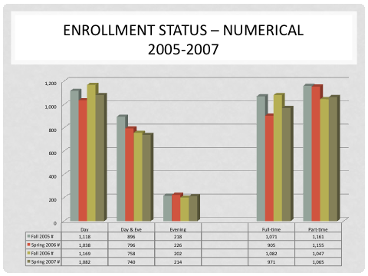

Figure 2a. EVC English Department: Enrollment Status—Numerical

Fall 2005-Spring 2007

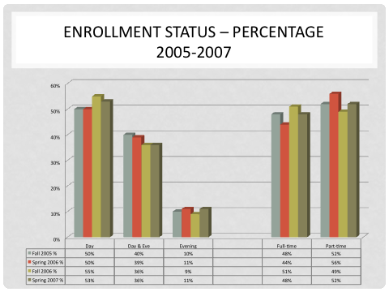

Figure 2b. EVC English Department: Enrollment Status—Percentage

Fall 2005-Spring 2007

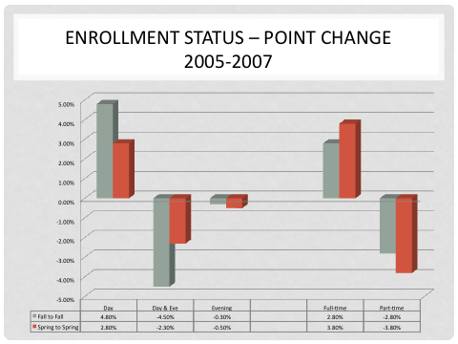

Figure 2c. EVC English Department: Enrollment Status—Point Change

Fall 2005-Spring 2007

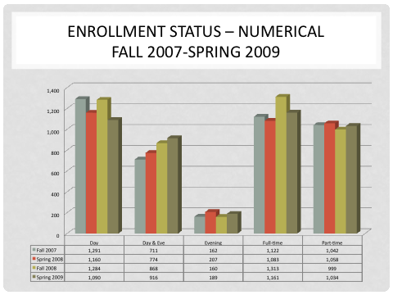

Figure 2d. EVC English Department: Enrollment Status—Numerical

Fall 2007-Spring 2009

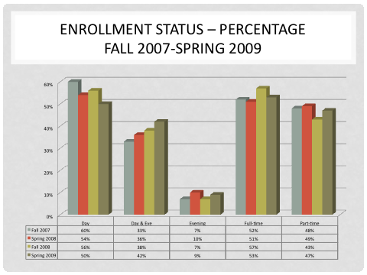

Figure 2e. EVC English Department: Enrollment Status—Numerical

Fall 2007-Spring 2009

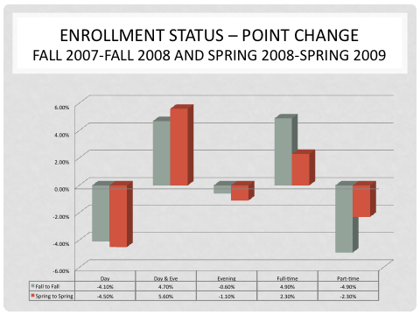

Figure 2f. EVC English Department: Enrollment Status—Numerical

Fall 2007-Spring 2009

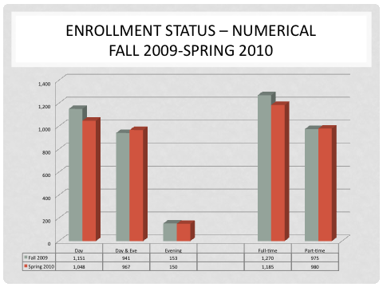

Figure 2g. EVC English Department: Enrollment Status—Numerical

Fall 2009-Spring 2010

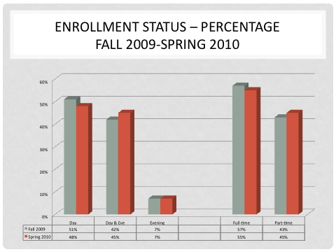

Figure: 2h. EVC English Department: Enrollment Status—Numerical

Fall 2009-Spring 2010

**8. Identify department/program productivity.**

The English Department/Program is consistently productive, with the WSCH/FTEF reaching or exceeding thebenchmark.

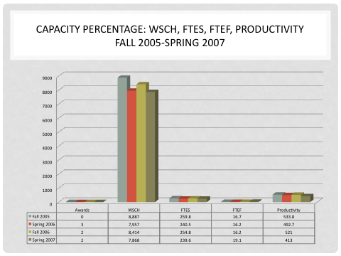

Figure 2i. EVC English Department: Enrollment Status—Numerical

Fall 2007-Spring 2009

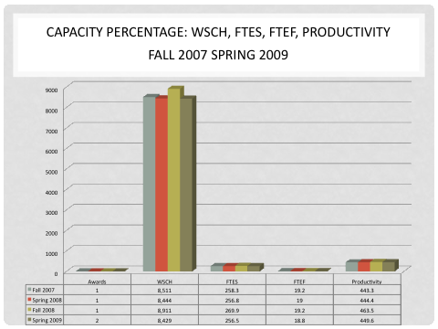

Figure 2j. EVC English Department: WSCH, FTES, FTEF, Productivity

Fall 2007-Spring 2009

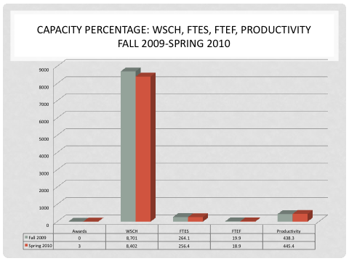

Figure 2k. EVC English Department: WSCH, FTES, FTEF, Productivity

Fall 2009-Spring 2010

**9. Identify student success rate and patterns within the department/ program paying particular attention to our college’s target groups.**

Student, retention, performance, and ultimate success in EVC’s rigorous literature classes demonstrate how, contrary to what some believer, EVC’s students rise to the occasion rather than cower when challenged. Between the Fall Semester 2005 and Spring Semester 2010, **student retention** in English Literature classes ranged from **81% to 91%.** Apart from one class, the **student success** rate tended to be somewhere between **71% and 85%.**

At EVC, our dominate ethnic populations—especially target groups— represent the bulk of our most recent English Majors—majors who plan on teaching or related work. Some have cited this fact as one of the most encouraging patterns that has evolved since the 2000 EVC English Program Review. See *EVC English Major Data Graphs and Analysis* in Appendix E—figures 01 to 012—for a detailed look at English Majors on campus.

**10. If the program utilizes advisory boards and/or professional organizations, describe their roles.**

The CSU English Council and the English Council of California Two-Year Colleges functions as a professional resource and advocacy body to inform best teaching practices in college English

## PART B: Curriculum

1. ***Identify all courses offered in the program and describe how the courses offered in the program meet the needs of the students and the relevant discipline(s).***

**District Curriculum Website Date of Approved Outline/Notes**

English 1A: English Composition 2006

English 1B: English Composition 2006

English 1C: Critical Thinking/Composition 2006

English 1L: English Composition Lab 2003 (Rev. in progress)

English 21: Introduction to Poetry 2004

English 28: Introduction to World Mythology 2000 (Rev. in progress)

English 33: Women in Literature 2001 (Rev. in progress)

English 35: The Short Story 2000

English 52: Children's/Adolescent Literature 2005 (Rev. in progress)

English 60: Japanese and Japanese-American Lit. 2000

English 62: Asian/Asian-American Literature 2006

English 72: Fundamentals of Creative Writing 2002 (Rev. in progress)

English 73: Introduction to Shakespeare 2003 (Rev. in progress)

English 80: Mexican American Literature 2007

English 82A: African American Literature 2002 (Rev. in progress)

English 84A: Survey of American Literature 2007

English 84B: Survey of American Literature 2007

English 86A: Survey of English Literature I 2007

English 86B: Survey of English Literature II 2007

English 98: Directed Study None

English 99: Grammar for Writers: WST Preparation 2006

English 104: Fundamentals of Composition 2010

English 330: Improvement of Writing 2003 (Rev. in progress)

English 341: Sentence/Paragraph Development 2006

Humanities II: Introduction to World Literature 2007

All current course revisions will be completed by the Fall Semester 2011.

Many of the students entering Evergreen Valley College need remediation in English, including native speakers, non-native speakers, and Generation 1.5 students. Recent data shows that the student population of our largest feeder district, the East Side Union High School District, consists of nearly 30% English language learners. **Demographics Question: how many students test into English 1A, how many into 104, 330, or 341?**

The most recent pedagogy indicates that students who begin their college writing below the English 1A level make more consistent progress if their course work is supplemented by focused work in the Writing Center. English 104 and 330 include three hours of work (impromptu essays and other activities) each week in the Writing Center, which, since it represents one unit in a four-unit course, counts as 25% of each student’s grade. To ensure their readiness for the next level, students in English 1A, 1B, 104, and 330 composition courses take a holistically scored departmental final examination which counts for 20% of their course grade.

English 1A is required to complete an Associate degree at Evergreen Valley College. English 1C fulfills the critical thinking IGETC requirement on any CSU or UC campus. English 1B, 21, 28, 35, 52, 73, 84A, 84B, 86A, 86B, and Humanities II fulfill humanities requirements, and English 33, 60, 62, 80, and 82 EVC’s cultural pluralism/ethnic studies requirements and humanities requirements.

In the Fall Semester 2010, we offered 28 sections of English 1A; 11 sections of English 1B; 6 sections of English 1C; 2 sections of English 1L; 1 section of English 80; 1 section of English 99; 16 sections of English 104; 7 sections of English 330; and 5 sections of English 341. We offered 1 section each of English 28: Introduction to World Mythology; English 33: Women in Literature; English 82: African American Literature; English 84A: Survey of American Literature I; and English 86A Survey of English Literature II. Included in these totals are Affirm sections of 1A, 104, and 330, and Enlace sections of 1A and 104.

In the Spring Semester 2011, alternating with fall sections of English 28, English 33, English 82A, English 84A, and English 86A, we will offer 1 section each of literature courses English 62: Asian/Asian-American Literature; English 72: Creative Writing; English 73: Introduction to Shakespeare; English 84B: Survey of American Literature II; English 86B: Survey of English Literature II.

1. **State how the program has remained current in the discipline(s).**

Faculty members regularly attend conferences ranging from the local to international level. Several faculty members serve in leadership positions in national professional organizations, several are certified in holistic scoring, and several hold certificates in multiple subject areas, including reading and teaching English to speakers of other languages. We offer learning community courses in partnership with other departments including reading, humanities, and philosophy. Many faculty members teach online or web-enhanced courses. Currently we offer one section of English 1A online and plan to expand our online offerings to English 1B and English 1C.

While the English Instructors at Evergreen Valley College have been acknowledged as experts in the field of composition and literature, they take nothing for granted and continue to work on professional development even in the absence of funds and encouragement. To this end, they attend and present at national, statewide, and local conferences; write professional articles and books; subscribe to and read journals such as *inside english* (put out by the English Council of California Two-Year Colleges) and *TETYC*—Teaching English In Two-Year Colleges (published by the National Council of Teachers of English (NCTE) and the national Two-Year College English Association (TYCA).

A breakdown of professional English organizations and/or conferences that inform Evergreen Valley College English Professors and enable them to maintain currency in their field include:

* *CCCCs: College Conference on Composition and Communication*
* *CCHA: Community College Humanities Association*
* *ECCTYC: English Council of California Two-Year Colleges*
* *MLA: The Modern Language Association*
* *NCTE: The National Council of Teachers of English*
* *TYCA: The Two-Year College English Association*
* *YRC: The Young Rhetoricians’ Conference*
* *ETS: The Educational Testing Service*

Members of the EVC English Department do far more than simply attend and present all key conferences in college English, however. Since the inception of EVC’s English Department, they have filled key leaderships roles—roles that enable them to maintain contact with other nationwide professions in their field. They epitomize the “teacher/scholar,” people dedicated to teaching and learning but at the same time remaining involved in the sort of research and writing done less to validate themselves—or esoteric theories—than to share informed pedagogies, best teaching practices, critical/creative thinking, and reading, and writing strategies. They exert an unpretentious, commanding voice in the national conversations on the teaching of English, especially regarding issues affecting diverse student populations.

1. **All course outlines in this program should be reviewed and, if appropriate, revised every six years. If this has not occurred, please list the courses and present a plan for completing the process. (Curriculum recency)**

The English Department created SLOs for almost all courses back in 2005 and revised them once since then. However, many did not find their way to the curriculum committee for one reason or another. The department is in the process of updating or discontinuing the following courses:

English 1L: English Composition Lab 2003 (Rev. in progress)

English 21: Introduction to Poetry 2004

English 28: Introduction to World Mythology 2000 (Rev. in progress)

English 33: Women in Literature 2001 (Rev. in progress)

English 35: The Short Story 2000

English 52: Children's/Adolescent Literature 2005 (Rev. in progress)

English 60: Japanese/Japanese-American Lit. 2000 Discontinued

English 72: Fundamentals of Creative Writing 2002 (Rev. in progress)

English 73: Introduction to Shakespeare 2003 (Rev. in progress)

English 82: African American Literature 2000 (Rev. in progress)

English 98: Directed Study None

English 330: Improvement of Writing 2003 (Rev. in progress)

**Timeline:** Within the next year, all composition and literature courses will be updated whether they need it or not.

1. **Identify and describe innovative pedagogy your department/program developed/offered to maximize student learning and success. How did they impact student learning and success?**

**Innovative Writing Center**

* Portfolio Assessment
* Constant updating of Writing Center Curriculum to reflect current events and issue relative to the lives of our diverse student population.
* Mentoring and training Writing Center 1) instructors, 2) student interns, and 3) classified staff in current writing pedagogy.

Students who pass the Writing Center component of precollege classes (one unit of a four-unit class taught in a writing center environment) are better prepared to pass the final examination, thus succeeding in college level classes and/or writing in the work force.

**Holistically Scored Composition Final Examination**

Contrary to practices at other community colleges around the country, for almost twenty years, all EVC composition classes have:

* shared a common final exam—including developmental classes and their parallel ESL classes.
* convened all fulltime and adjunct writing instructors at least twice yearly to establish grading standards and norms.
* reviewed and revised (as needed) holistic scoring guides three times yearly; these guides serve as lists of SLOs for each composition level.
* conducted training workshops in holistic assessment for new faculty.

Scoring guides for all four levels of composition mirror the standards set by the CSU system, thus ensuring student success after transfer.

Accolades for the Evergreen Valley College Writing Center and the English Composition Departmental Final have been ongoing since the last English Program Review in 2000. In the past six years, our constant accomplishments have been cited in *inside english (journal of the English Council of California Two-Year Colleges)*, *TETYC (Teaching English in Two-Year Colleges)*, as well as in the national reports issued by the TYCA (Two-Year College English Association) Research Initiative Committee.

TYCA further recognized 1) EVC’s Department Final Exam in terms of "Best Writing Assessment Practices for Diverse Student Populations," and 2) EVC’s Writing Center, which received a national honorable mention in the “*Diane Hacker Best Program Award”* category as the “best student centered” writing center in the United States.

**Evergreen Valley College English AA**

* Since 1995, EVC has offered an AA in English.
* EVC’s English Literature program enrollment has grown exponentially.
* Since the last Program Review in 2000, the English Department added courses to curriculum offerings such as Children’s/Adolescent Literature.
* The English Department offers—and fills—five to seven literature courses every semester, and we could fill more with the resources to add sections.
* EVC literature courses offer widely diverse, multicultural selections that expand awareness of the world and the written word.
* The department’s updating all current literature courses offered by EVC.
* Possible future classes:

ENGL Bible as Literature 3.0

ENGL 20th Century Fiction 3.0

ENGL Gothic Literature 3.0

1. **Discuss plans for future curricular development and/or program (degrees & certificates included) modification. Use the Curriculum Mapping form to lay out your plan.**

* In accordance with English AA programs across the state, the EVC English Program has adopted “program SLOs.”
* Faculty in the English Department are currently updating its English Major Sheet (core classes, elective classes, and cultural pluralism classes).
* A draft of the revised EVC English AA pamphlet will be competed by June 1, 2011.
* On a semester basis, the English Department will continue to consistently revise and update Writing Center Curriculum.
* The English Department faculty provide all counselors with a frequently updated handout called “What Can One Do With an English Major” (see appendix for a copy of it) that informs students and counseling staff alike on the many reasons an English major or minor may lead to student success and distinction almost any field.
* **Suggestion:** We might devise a way to track the numerous EVC English Majors who transfer to a four-year college but do not bother to complete the AA degree in order to keep a better record of the students who benefit from the thriving English AA Program. This would require funding that we do not currently have, yet in this data driven era, we would be doing future students a real favor by collecting such information to defend our future needs as well as theirs.

1. **Describe how your program is articulated with the High School Districts, CCOC (if applicable), and/or other four year institutions. (Include articulation agreements, common course numbering etc.)**

The Evergreen Valley College English Department does not have any formal articulation with local high schools. However, it does work closely with other four year colleges and universities in the following ways:

* EVC English Faculty has a long history of working with the WST at SJSU in particular and the GWAR in the CSU system in general.
* One of the English Department Faculty members to be the WST coordinator at SJSU, providing the EVC campus with expertise on how students can prepare for the junior proficiency writing test required of four-year-college transfer students.
* Since the 2000 EVC English Program Review, other faculty continue to work with four-year colleges in various capacities, including the ECCTYC liaison to the CSU/UC Composition Coordinators.
* Faculty members have initiated numerous projects and partnerships with four-year colleges such as San Jose State University and will continue to do so.
* Through work with CSU and ECCTYC English Council, the EVC English Department looks forward to establishing several partnerships in the near future, including those that deal with graduate interns and community college mentoring.
* Presently, to build trust at both institutions, EVC management must cease to commandeer educational partnerships and respect—and enable—English Department efforts with four-year colleges; faculty members—not management—have been and will continue to be the experts in education.

1. **If external accreditation or certification is required, please state the certifying agency and status of the program.**

***Not Applicable.***

**EVC English Major Data Graphs**

**(Spring 2009 to Spring 2011)**

The Evergreen Valley College English Department conducted random data collection surveys in several classes—including British Literature, American Literature, World Mythology, and Creative Writing since the from the Fall Semester 2009 to the Spring Semester 2011. Students filled out English Major Data Cards that provided information on student demographics; such English Major statistics assessed gender, ethnicity groups, and English AA Degree and/or transfer patterns.

The following notes and specific graphs offer an ethnographic snapshot that profiles current and future English majors—many of whom plan to become instructors of composition, critical thinking, and literature at all levels of academia. Overall, the data-sampling representative of English Majors yielded some rich, encouraging, albeit unanticipated details, in some instances. NOTE: the EVC English Major findings are based on a study of 85 representative students.

In particular, we want to thank the 85 English Majors who freely participated in our data research. We will begin to follow-up this initial study by requesting that new and returning English Majors in all literature classes fill out data cards (to be housed with English Faculty Advisors Sterling Warner and Nancy Wambach).

**Figure 01.** Snapshot of EVC English Majors: Gender (Numerical) 2009-2011 Graph

As the above graph indicates, we presently have more female than male English Majors at EVC. *See* ***Figures 08a & 08b.*** *Snapshot of EVC English Majors: Alternate Aggregated Gender & Ethnicity (Numerical) Fall 2009-Spring 2011 Graph* for a look at EVC English Major statistics broken down by gender as well as ethincity.

The random sampling of current and a few past English Majors at Evergreen Valley College revealed that female outnumbered male English Majors by 20% (60% female to 40% male, respectively). However, none of this comes as much of a surprise. Continuing growth in enrollment in degree-granting institutions has been reflected by an increase in the number of degrees conferred.

Increases in the number of degrees conferred are expected to continue between 2006–07, the last year of actual data, and 2018–19 (“Projections of Education Statistics to 2018,” William J. Hussar).

**Figure 02.** Snapshot of EV English Majors: Gender (Percentage) Fall 2009-Spring 2011

“Projections of Education Statistics to 2018” foresees a continued increase in the number of degrees; Associate Degrees alone will rise by 25%. This breaks down to a 16% increase in Associate Degrees for men and a 31% swell in Associate Degrees for women (Hussar). In other words, the rise in the number of degree seeking female college students tends to be a statewide—as well as nationwide—pattern. While a pattern of women outnumbering men exists at EVC when considering AA Degrees in general, the Associate Degree in English at Evergreen Valley College shows no such disparity between genders. We have witnessed no achievement gap—when comparing male and female English AA candidates in terms of sheer numbers. *See* ***Figure 03.*** *Snapshot of EVC English Majors: English AA Track Gender (Numerical) Fall 2009-Spring 2011.*

**Figure 03.** Snapshot of EVC English Majors: English AA Track Gender (Numerical)

Fall 2009-Spring 2011

Interestingly, while we tend to have about the same number of male and female students who identify themselves as being on an English AA Track, far more females identify their English Major goal at EVC to Transfer to a four-year college to earn their Bachelor’s Degree in the discipline. *See* ***Figure 4.*** *Snapshot of EVC English Majors: English AA Track Gender (Percentage) Fall 2009-Spring 2011.*

**Figure 04.** Snapshot of EVC English Majors: English AA Track Gender (Percentage) Fall 2009-Spring 2011

According to “Projections of Education Statistics to 2018” published in September 2009, “Between 1993–94 and 2006–07, the number and proportion of degrees awarded to women rose at all levels” (William J. Hussar 14). However, this is not totally true when assessing discipline specific AA degrees. Compare female and male EVC English AA and Transfer patterns (***Figure 05*** *and* ***06****)* below.

**Figure 05.** Snapshot of EVC English Majors: English Transfer vs. AA--Female (Numerical) Fall 2009-Spring 2011

**Figure 06.** Snapshot of EVC English Majors: English Transfer vs. AA--Male (Numerical) Fall 2009-Spring 2011

Snapshot of EVC English Majors:

Gender—English Track Goals (Numerical)

Fall 2009 Spring 2011

**Figure 07.** Snapshot of EVC English Majors: Aggregated Gender & Ethnicity (Numerical) Fall 2009-Spring 2011 Graph

Both male and female English Majors continue to grow in numbers at Evergreen Valley College—majors who represent the diverse demography of our student population on campus. This pattern bodes well not only for the English AA Program at EVC but for the future of profession as well. Why? Although an English AA or BA can provide a great background for any number of careers, a large portion of our English Majors—whether they intend to earn an English AA from EVC or and English BA from a four year college or university—intend to become English Professors in their own right.

As stated in “What Can One Do with a Degree in English” (Warner), “While many majors go into teaching, library work, law, or graduate school in English, a growing number of students view the English major as a pre-professional degree, a degree that enhances their ability to write, think, and speak more effectively. As we move into the 21st century, degrees in English are blossoming; students considering careers in numerous fields find the English Major an ideal preparation for entry into their profession.” *(See* ***Appendix B*** *for the complete document.)*

Since the EVC English Department established its AA degree in 1995, many of our graduates have returned to campus as instructors, not only in English but other related areas such as Communications. In no small way should we consider this a minor commentary about the English AA, for it actively displays the concept of “giving back” to EVC in general and its English discipline in particular.

Snapshot of EVC English Majors: Aggregated Gender & Ethnicity

(Numerical) Fall 2009 Spring 2011

**Figure 08a.** Snapshot of EVC English Majors: Aggregated Gender & Ethnicity (Numerical) Fall 2009-Spring 2011 Graph

If we acknowledge a gender gap in terms of campus-wide AA degrees (apart from the English AA Track or Transfer Track), then we also must also concede that formerly, men had earned more AA degrees than women. Thus, the present number of degree bound female students (AA or BA transfer) amounts to little more than a reversal in what some might call a “gender gap.”

**Figure 09.** Snapshot of EVC English Majors: Aggregated Gender & Ethnicity (Numerical) Fall 2009-Spring 2011

Evergreen Valley College English Majors:

Gender, English AA Track, Transfer Track

(Number & Percentage) Fall 2009-Spring 2011

**African American**

**Total EVC English Majors: 5 5.9%**

***Male:*** ***2*** 40%

Transfer bound: 1 50%

EVC English AA Track: 1 50%

***Female:*** ***3*** 60%

Transfer bound: 3 100%

EVC English AA Track: 0 0%

**Asian**

**Total EVC English Majors: 16 18.8%**

***Male:* 6**37.5%

Transfer bound: 3 50%

EVC English AA Track: 3 50%

***Female:* 10**62.5%

Transfer bound: 6 60%

EVC English AA Track: 4 40%

**Filipino/Pacific Islander**

**Total EVC English Majors: 11 12.9%**

***Male:***  5 45.5&

Transfer bound: 3 60%

EVC English AA Track: 2 40%

***Female:*** 6 54.5%

Transfer bound: 4 66.7%

EVC English AA Track: 2 33.3%

**Latino/Hispanic**

**Total EVC English Majors: 28 32.9%**

***Male:*** 11 39.3%

Transfer bound: 7 63.6

EVC English AA Track: 4 36.4

***Female:*** 17 60.7%

Transfer bound: 12 71%

EVC English AA Track: 5 29.%

Evergreen Valley College English Majors: Gender, English AA Track, Transfer Track (Number & Percentage) Fall 2009-Spring 2011 *(Continued)*

**Native American**

**Total EVC English Majors: 0 0%**

***Male:*** 0 0%

Transfer bound: 0 0%

EVC English AA Track: 0 0%

***Female:*** 0 0%

Transfer bound: 0 0%

EVC English AA Track: 0 0%

**White/Caucasian**

**Total EVC English Majors: 21 26.25%**

***Male:*** 8 38.1%

Transfer bound: 4 50%

EVC English AA Track: 4 50%

***Female:*** 13 61.9%

Transfer bound: 9 69.2%

EVC English AA Track: 4 30.8%

**Other:**

**Total EVC English Majors: 4 4.7%**

***Male:***  2 50%

Transfer bound: 2 100%

EVC English AA Track: 0 0%

***Female:*** 2 50%

Transfer bound: 2 100%

EVC English AA Track: 0 0%

***Alternate Stats:* Asian/Filipinos/Pacific Islander (as one aggregate group)**

**Total EVC English Majors: 27 31.7%**

***Male:*** 11 **41%**

Transfer bound: 6 55%

EVC English AA Track: 5 45%

***Female:*** 1659%

Transfer bound: 10 62.5%

EVC English AA Track: 6 37.5

While we caution that all EVC Data on English Majors has been derived from **a raw** **sampling of 85 declared English Majors—**a representative rather than exhaustive enumeration of them—it nonetheless tends to be a rather accurate reflection of our students. Every semester we seem to encounter new English Majors—among all ethnicities, especially among Latino/Hispanic students and students who identify themselves as people proud of their multiple cultural heritages.

**NOTE:** When comparing aggregate data, however, some colleges still combine “Filipino/Pacific Islanders” with Asians. If we had done so, we would have ended up with 28 in the Latino/Hispanic group, 27 in the Asian/Pacific Islander/Filipino group, and 21 from the White/Caucasian Group.

**Figure 010.** Snapshot of EVC English Majors: Transfer/AA Comparison—Gender & Ethnicity (Percentage) Fall 2009-Spring 2011

Evergreen Valley College English Majors: Gender, English AA Track, Transfer Track (Percentage) Fall 2009-Spring 2011

**Figure 011.** Snapshot of EVC English Majors: Alternate Transfer/AA Comparison—Gender & Ethnicity (Percentage) Fall 2009-Spring 2011

**Executive Summary of EVC English Major Data:**

* With limited financial support, the Faculty Driven English Major here at EVC has flourished under the guidance of faculty advisors: Sterling Warner and Nancy Wambach. Before the Language Arts Dean, Keith Aytch, finalizes the English schedule for Fall and Spring semester, he works with EVC English Instructors to makes certain that the department offers all core and elective English Major classes at least once a year.
* Rather than working towards an English AA degree and a formal graduation, more and more, English Majors from Evergreen Valley College are electing to directly transfer into four-year colleges and universities upon the completion of their core and elective requirements.
* Any district research or conclusions about the success rate of English Majors must not be based on the number of associate degrees earned; rather, it should focus time, energy, and assessment on the increasing transfer function of not only EVC in particular but two-year colleges in general.
* Due to the economic crisis in California—a situation that FACCC (the Faculty Association of California Community Colleges) projects may not improve until around 2015 at best, any major shift in this practice seems highly unlikely outside of those seeking an AA as a terminal degree. Even so, many of our English Majors do earn their Associate of Arts Degree.
* A growing number of Business Majors seek to distinguish themselves as English Majors, strengthening their critical thinking and communication skills and thereby improving their business acumen and marketing ability.
* More and more, students of color have elected to become English Majors. This fact adds new light against the stereotypes associated with English Majors for the past 50 years.
* However, placing students in aggregated as well as disaggregated categories does not always reveal their accurate sense of identity. Why? About 35% of the students polled did not align themselves with a single cultural heritage but, rather, with two or more.
* For the purpose of this initial survey and assessment of EVC English Majors, I entered the first ethnicity listed for the comparative study—not both (e.g., Hispanic/Asian = Hispanic).
* The catchall category of “Other” does not do justice to complexities inherent in relating to multiple cultural heritages. Hopefully the District Office of Research and the EVC English Department will be able to work together to devise ways of collecting all data in relation to EVC English Majors in the future.

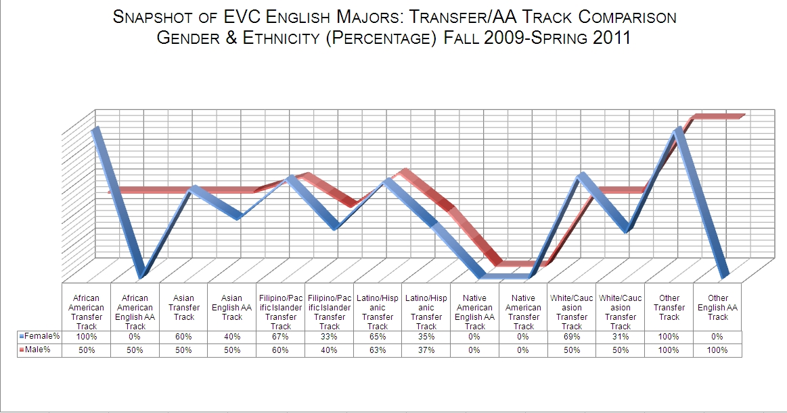

**Figure 012:** Snapshot of EVC English Majors: Transfer/AA Track Comparison

Gender & Ethnicity (Percentage) Fall 2009-Spring 2011

## PART C: Student Outcomes

## On the course level, list all the courses that have current student learning outcomes (included in the course outline) and provide link to the course outlines for review purpose. Provide a plan and timeline to include student outcomes for the courses that do not have one.

All courses offered and listed in Part B, except Short Story, have current student learning outcomes or course learning outcomes on file. These are available on the SJECCD intranet. Department faculty plan to update the outstanding courses by September 2011. The process is outlined as follows on the public website at: <http://www.evc.edu/about/slo.htm>

***SLO Implementation Timeframe for Courses***

*2009-2011 All courses submitted to the ACCC contain SLOs*

*2010-2011 Deadline for all courses to contain SLOs by the end of*

*Fall 2011 semester*

*Drop all courses that don’t meet the deadline in*

*Spring 2012 semester*

*2011-2012 Maintain SLOs in all courses*

***SLO Assessment Plan for Courses***

*2009-2011 Include testing methods*

*2010-2011 Begin dialog about how and what assessment methods will*

*work at the course level*

*2011-2012 Insert assessment language in Course Outline Form*

1. **On the program level, list all programs (and degrees) that have current student learning outcomes and provide the culture of evidence.**

(In October 2010, the English Department approved the following as “English AA Program SLOS; the curriculum committee needs to approve them too. They will be submitted n April 2011.

**EVC Associate in Arts Degree in English** *(Program SLOs)*

**SLO # 1.** Demonstrate knowledge of and familiarity with the methods of

interpreting literature across genres.

**SLO # 2.** Assess, evaluate, and analyze ideas expressed in text or in

spoken language.

**SLO # 3**. Create (write or present) coherent arguments that evidence clear

prose and synthesize diverse bodies of knowledge.

*(The English AA Program update—complete with the SLOs above—will be submitted to the EVC Curriculum Committee in December 2011)*

The Department lists the following on the public website for the Associate in Arts Degree at: http://www.evc.edu/degrees/10-11/english.pdf

*Students considering careers in advertising, communication, film writing, electronic and printing journalism, library science, public relations, publishing and editing, or teaching find the English major and ideal academic preparation for entry into these professions. In addition, the English major readies students for graduate programs, including communication, history, law, and medicine. Students must complete each major course and major elective course with a grade of “C” or better to be awarded the degree.*

***ASSOCIATE IN ARTS DEGREE UNITS Core Classes***

*ENGL 001B English Composition 3.0*

*ENGL 084A Survey of American Literature 3.0*

*ENGL 084B Survey of American Literature 3.0*

*ENGL 086A Survey of English Literature I 3.0*

*ENGL 086B Survey of English Literature II 3.0*

***Total Core Units 15.0***

***Major Electives***

*Select three courses from the following list:*

*ENGL 021 Introduction to Poetry 3.0*

*ENGL 028 Introduction to World Mythology 3.0*

*ENGL 033 Women in Literature 3.0*

*ENGL 072 Fundamentals of Creative Writing 3.0*

*ENGL 073 Introduction to Shakespeare 3.0*

*HUMNT 002 Introduction to World Literature 3.0*

***Other Electives***

*ENGL 052 Children’s’/Adolescent Literature 3.0*

***English Courses that meet the Humanities/Cultural Pluralism***

***Requirements:\****

*ENGL 033 Women in Literature*

*ENGL 060 Japanese & Japanese-American Literature*

*ENGL 062 Asian/Asian American Literature*

*ENGL 080 Mexican American Literature*

*ENGL 082 African American Literature*

***Major Core 15.0***

***General Education Requirements 39.0***

***Major Electives 9.0***

***Total Units 63.0***

The EVC English Department’s “culture of evidence” evolves from faculty expertise and practices that support and integrate research, data analysis, evaluation, and resource augmentation/change. Moreover, professional national studies such at the TYCA Research Initiative further inform the EVC English Faculty’s decision-making. Also, the student-centered, “faculty-driven” assessment updates those “outside the classroom” about learning realities, and provides them with verifiable, timely evidence to advocate the uphill battle addressing student/faculty needs.

1. **List or describe all assessment mechanisms you are using to evaluate SLOs. Provide results of analysis.**

**Composition Classes**

The main assessment mechanism for course level SLOs is the departmental final, where all department faculty members gather as a group over a two –day period and holistically score 330, 104, and 1A essays (as well as any parallel ESL composition classes) at the end of the semester. Other department courses also employ portfolio review to evaluate SLOs.

Overall results are quite positive. Even though SLO pundits have extolled the holistically scored final exam as a “model measurable SLO assessment mechanism” on EVC’s past two accreditation reports—also highlighted in the 2000 English Department Program Review—the exam predates concept of SLOs by a decade. Thus, abundant evidence exists that the faculty driven assessment process—rather than the creation of SLOs—has anything to do with accurately measuring what we now refer to as “student outcomes.”

**Literature Classes**

Demonstration of core competencies, including the recognition of elements of all major literary genres–non-fiction, fiction, poetry, drama; the identification of characteristics in literary works from diverse authors, places, and times; and the defense of a literature interpretation citing textual evidence; enable English Faculty to assess program level “literature” SLOs. (Note: Naturally, each literature class has similar—yet some different—SLOs dependent upon the genre studied).

Successful English Program level SLOs have been assessed in a variety of ways: homework, quizzes, exams, essays, presentations, etc. For instance, throughout each semester, students will periodically read, synthesis information, and respond to a prompt for a representative text, and they will write a coherent, well-supported and properly cited essay advancing a literary interpretation of that text.

The ongoing assessment of measurable EVC English Department SLOs began around 1996, a year after it created an AA in English, and it continues to the present. While English faculty members respect “academic freedom” in instruction on one hand, they remain answerable to themselves on the other. Thus, all comply to Program Level SLOs, making assessment of their relevancy and effectiveness possible at department meetings, during greensheet development (two to three times each academic year), and when updating department course outlines.

## PART D: Faculty and Staff

1. **List current faculty and staff members in the program, areas of expertise, and how positions contribute to the program success. 2. List major professional development activities completed by faculty and staff in this department/program in the last six years and state proposed development and reasoning by faculty in this program.**

**Full-Time Instructors:**

**Sravani Banerjee:**

**B.A. English Literature, St. Xavier’s College, Calcutta, India**

**M.A. English Literature, San Jose State University, San Jose, California**

**Areas of Expertise:** Developmental and advanced composition courses which include English 300, English 104, English 1A, and English 1B, English Literature, Asian and Asian-American Literature, and ASPIRE courses.

How My Position Contributes to Program Success: Professor Banerjee teaches all levels of English composition. She also teaches in the ASPIRE (Asian and South Pacific Islander Resources for Excellence) Program which focuses on the academic success of the Asian and South Pacific Islander community at Evergreen Valley College. Her own immigrant background gives her a unique perspective on the specific needs of our large immigrant student population. Additionally, Professor Banerjee teaches in the Writing Center for students in our developmental courses and the IL lab for students in English 1A, English 1B and English 1C. She also teaches the Asian and Asian-American Literature class in the spring semester. Furthermore, Professor Banerjee incorporates Service Learning in all her classes, and she develops and teaches in Learning Communities, combining writing and reading classes such as English 322/ English 330 and English 104/ English 102

Professional Development in the Past Six Years: Professor Banerjee regularly presents at local and international conferences and workshops such as the YRC (Young Rhetoricians’ Conference) and the ECCTYC Conferences on college composition and rhetoric. She currently serves as the ECCTYC (English Council of California Two-Year Colleges) Region III Co-director. In 2008, she spent a week in Salzburg, Austria at the Salzburg Global Seminar for educators. She has published articles and poems in literary journals and in textbooks. Professor Banerjee serves as an advisor for the Aspire Program, the Honor’s program and the Desi club on campus. She has served as a mentor to new and adjunct faculty. Currently, Professor Banerjee serves on the Academic Senate and on the College Council.

**Robin Hahn**

**B.A. English, San Jose State University**

**M.A. English with Certificate in Composition, San Jose State University**

**Certificate in Reading, San Francisco State University**

**Certificate in TESOL, San Jose State University**

**Certified reader for Educational Testing Service’s Test of English as a Foreign Language (TOEFL iBT)**

**Areas of Expertise:** ESL and Generation 1.5 composition;composition/critical thinking, women in literature, online education.

**How my Position Contributes to Program Success:**

Ms. Hahn teaches courses in three disciplines (English, Reading, and ESL) serves as a table leader for holistic scoring in the English and ESL departmental final, coordinates and maintains records for the English 1C faculty committee, and is a member of the College Budget Committee and Womyn’s Herstory Committee.

**Professional Development in the Past Six Years:**

2005: Session chair for technology presentations at Young Rhetoricians Conference; 2007: Selected as one of 3 delegates from EVC to the Salzburg Seminar on globalization of the community college in Salzburg, Austria; 2007: Presented “Building Global Competences in the Language Arts Classroom” at ECCTYC conference with Carmen Solorzano of the Foreign Language Dept*.;* 2008: Presented “Preparing ESL Students for College Writing: A Multi-Disciplinary Discussion” at August PDD with Lana Strickland of the ESL Dept.; 2009: Presented “Introduction to Moodle” and “Building Courses with Moodle” at August PDD with Nasreen Rahim of the Educational Technology Dept.; 2010: Moderated “Momma Didn’t Raise No Fools”: Critical Thinking/Argumentation session at Young Rhetoricians’ Conference; 2010: Began work in @ONE Online Teaching Certification Program.

**Todd Marvin**

**B.A. English Literature, San Jose State University**

**M.A. English (Concentration in Writing), San Jose Sate University**

Areas of Expertise: College-level Expository Prose, Pre-college Composition, Creative Writing, Holistic Scoring, Advanced Grammar

How My Position Contributes to Program Success: Professor Marvin has been Co-Coordinator of the Writing Center since 2006. The WC specializes in preparing students for moving through the developmental writing program to success in transfer-level English Classes. He has also taught English 99 for the last ten years; this course has been essential in aiding those EVC students transferring to San Jose State University (as well as other CSU institutions) by focusing on passing the state-mandated Graduating Writing Assessment Requirement (GWAR). He has also served as a Chief Reader and Table Leader for the English Department's final exam for the last sixteen years.

Professional Development in the Past Six Years: Professor Marvin's major professional achievement has been earning tenure. In doing so, he has continued writing and submitting fiction for publication, sat as an invited, non-voting member on San Jose State University's Writing Requirements Committee, and developed extensive curriculum supporting the English Department's holistically scored final exams.

**Steven Mentor**

**B.A. English: Literature University of Pennsylvania**

**M.A. Composition and Rhetoric: San Francisco State University**

**Ph.D English and Technology Studies: University of Washington**

**Areas of Expertise:** Contemporary composition theory and pedagogy; Online teaching theory and practice; British and American Literature; Science fiction and creative nonfiction; Critical Thinking; history of cybernetics and the figure of the cyborg; and Critical theory and modernism/postmodernism.

**How your Position Contributes to Program Success:** For fourteen years, he has taught four English 1A courses every year using contemporary composition theory; for the past six years he has taught the only fully online course in the Department. He has worked collaboratively with other Critical Thinking instructors to produce and maintain a challenging and consistent English 1C course in critical thinking and writing, and has taught critical thinking each year for the last nine years. At different times, he has served as a mentor and hosted listservs for adjunct 1A and 1C teachers here at EVC, and regularly observes other faculty. In addition, he has taught literature for ten years at the community college level, and has joined other literature teachers in promoting an English Major here at EVC (one of the few community colleges to offer this major) and helping our literature students move on to graduate school and teaching positions. He has taught every level of English from 330 to 104 to 1A and 1B to 1C, and so has a realistic and program-wide view of courses and necessary student outcomes; in addition, besides teaching upper level courses, he teaches in the 330/104 Writing Lab each semester, and so keeps in touch with developing writers’ needs and styles of learning. Finally, for the past ten years he has represented the English Department and the Language Arts Division on the Campus Technology Committee, and been an advocate for faculty and students in our program in the purchase and development of instructional and workplace technology.

**Professional Development in the Past Six Years:** In a parallel fictional universe, with funding from the state and from the college, Dr Mentor has attended several excellent conferences on distance learning, technology and education, and teaching critical thinking and literature in a community college setting. Unfortunately the school has had no money. So his professional development has been limited to free virtual conferences and sessions devoted to online learning through the @One foundation, and membership in listservs like EduCause and California Virtual Campus. In addition, he sits on committees like English 1C and the Distance Education committee which function in part as education and professional development forums. And he keeps abreast of developments in his field by reading journals such as *College English*, *Teaching English in the Two Year College*, and several others.

In the past six years, Dr. Mentor has also published papers, and given talks at various conferences. The main talks have been:

“War, Gender, and Cyborgs.” Madrid, Spain June, 2009. Universidad Complutense de Madrid

International Leadership Association Conference

“Guides, Card Players, and Jazz: A Linguistic Map of Leadership.” In

“leadership: Power and Resistance in the Interstices.” Panelist.

**Recent publications:**

“The coming of the Mundane Cyborg.” Tekno Kultura: Online *Journal of Technology and Culture*. Publication date: December 2010. http://teknokultura.uprrp.edu/

“The Machinery of Consciousness: a Cautionary Tale.” *Anthropology of Consciousness*. Special journal issue on "The Consciousness Studies Industry", vol. 18, no. 1. 2007. 20-50.

**Keenan Norris**

**B.A. UC Riverside. M.F.A.: Mills College. M.A.: UC Riverside**

**Areas of Expertise:** African-American Literature. 20th Century American Literature. On-Line Teaching via Moodle, ETUDES, BlackBoard, Web-CT.

How My Position Contributes to Program Success: Norris’ is responsible for teaching Basic Skills, transfer-level and literature courses. He also works extensively with AFFIRM through the Rites of Passage and Mentor Programs. He teaches African-American Literature. He uses contemporary literature, a variety of media, and an evolving pedagogy to teach 1 series and Basic Skills classes. Norris’ teaching load is split pretty evenly between 1 series and Basic Skills classes. He finds his teaching methods effective and dynamic and encourages student interest, retention and matriculation.

Professional Development in the Past Six Years: In May 2005 Norris finished his M.F.A. at Mills College and began teaching in the fall of that year as an adjunct instructor at College of Alameda. Over the following two years he taught at Alameda, Ohlone College, Diablo Valley College and Los Medanos College. he learned a great deal about teaching, as well as Academic Senate procedure (he served as Alameda's part-time teacher's representative on the Senate) in these two years. In 2007 Norris entered the M.A./PHD program at UC Riverside. Concurrent with that program, he began teaching on-line at College of Alameda, Riverside Community College and at San Jose City College. The nature of study in the M.A. program, particularly the intense focus on literary criticism improved his analytical capabilities. He also gained much familiarity with Asian-American Literature. Teaching on-line greatly expanded my usefulness as an instructor; he feels that he is of more value to my institution because of it.

In 2009, upon completion of his M.A., Norris was hired at Evergreen Valley College. He has since worked full-time for EVC teaching Basic Skills, transfer-level and literature courses. He teaches brick-and-mortar and on-line courses. teaches AFFIRM courses, and works extensively in all aspects of the planning, organization and student outreach that AFFIRM performs. This has included conducting a workshop at the 2009 UMOJA Conference, contributing to AFFIRM's newsletters and working extensively on the Haiti Tribute. He has made himself an active part of the EVC faculty, working as table leader for the Spring Final Exam, helping to create topics for the 1B Final Exam and contributing to *Leaf by Leaf*.

Richard Regua

B.A. English, San José State University.

M.A. Mexican American Graduate Studies, San José State University

Area of Expertise: English Composition, American Literature, Chican@ Literature, Asian American Literature, Ethnic Studies, Mexican American Studies.

How My Position Contributes to Program Success: Professor Regua has 40 years of teaching experience at the high school and college level. In addition to teaching general composition and literature courses, he has taught in two culture conscious programs in the SJECCD District, first as a member of the Mexican American Studies Department at San José City College and since 1983 as a member of the Enlace Program of Evergreen Valley College. He has served as the Enlace Program Coordinator for the past 15 years. He has served as Principal Investigator for two successful Title V Hispanic Serving Institutions Projects at EVC, both projects designed to increase the retention, success, and transfer rates of Latin@ students.

Professional Development in the Past Six Years: Professor Regua has presented on the Enlace Program at several conferences, including the Congressional Hispanic Caucus on Hispanic Post-Secondary Student Success, Hispanic Association of Colleges and University (HACU) National Conference, Excelencia in Education Conference on Hispanic Student Success, Southwester Regional Title V HSI Best Practices Conference, and American Federation of Teachers-National Educators Association Joint National Conference.

**William Silver**

**B.A. English from the State University of New York, Buffalo**

**M.A. English and Creative Writing, Stanford University**    
  
**Areas of Expertise:** Professor Silver's areas of expertise include developmental writing, psycholinguistics, composition and rhetoric, introduction to literature, modern poetry, the history of the novel in Western literature, creative writing, and technology in education.

**How Your Position Contributes to Program Success:** His contribution to the English program's success comes from his commitment to individualized instruction in basic writing courses such as English 330 and English 104, where he helps to educate and support students who need preparation for college level writing and research courses.   
  
**Professional Development in the Past Six Years:** He read for an M. Phil. degree at the University of Sussex, England, in English Literature. His dissertation applied the insights of American rhetorical criticism and German reader-response criticism to the work of Miguel de Cervantes and William Faulkner.

In the last six years he has pursued professional development in several different areas, including learning two course management systems (Blackboard and Moodle), learning the features of Microsoft Office 2007, reading in the theory and practice of ESL instructional methods over the last half century, and development of basic French language competence.

**Hyeseong Lana Strickland**

**M.A. English, San Jose State University**

**M.A. TESOL, San Jose State University**

**Areas of Expertise:** Developmental and transfer English Composition,  Asian and Asian-American Literature, and English as a Second Language.

**How My Position Contributes to Program Success**: I use my experience as an immigrant and English as a second language learner to guide and motivate students to better understand how to use the English language effectively.  I have developed new courses--Asian-American Literature, English 341, ESL 315 and ESL 93 as well as new labs--English 1L and ESL Writing Seminars in order to enhance student success.  I have also served as the ESL Department Coordinator and ESL Lab Coordinator.

**Professional Development in the Past Six Years:** I have regularly attended local TESOL conferences each year and Young Rhetorician's Conference in 2008.

**Nancy Wambach**

**B.A. English and Latin, University of California, Santa Barbara**

**M.A. English, San Jose State University**   
  
**Areas of Expertise:**  American Literature, Women in Literature, Creative Writing, Shakespeare, Grammar for Writers.   
  
**How My Position Contributes to Program Success**:  Co-Director, EVC Writing Center; Coordinator, Composition Final Examinations; Co-Chair, Women’s Studies Department; Co-Chair, Women’s Herstory Month Celebration Committee; Member, Honors Advisory Board, numerous hiring and tenure review committees.   
  
**Professional Development in the Past Six Years**:  Advisory Board Member/Teacher Consultant, Bay Area Writing Project; Member, San Jose State University Writing Requirements Committee; Chief Reader of national and international writing exams, Educational Testing Service; Fellow, Salzburg Institute; Fellow, Prague Writers Institute.

**Sterling Warner**

**B.A. English, San Jose State University**

**M.A. English: Language Arts and Literature, San Jose State University**

Area of Expertise: Developmental and college level Composition and Rhetoric, Literature (World Mythology, World Literature, Shakespeare, Children’s/Adolescent Literature, and Survey of English Literature), Critical Thinking, and Creative Writing. Warner’s expertise lead him to write to several “cutting edge” basic writing texts—including *Visions Across the Americas*—the first multicultural reader/rhetoric published in 1991 (he’s now writing the 8th edition of the text); *Projections*, a cultural literacy reader rhetoric;a transfer composition/reader/research text, *Threshold*s; and a text design to meet the growing popularity and success of transfer Learning Communities, *Anthology of World Literature and Introduction to Theatre.* His critical essays, literary research, and poetry have appeared in many scholarly journals and anthologies. Since 2005, Warner also published two volumes of poetry—*Without Wheels* (2005) and *ShadowCat* (2008)—as well as a chapbook, *Memento Mori* (2010).

How My Position Contributes to Program Success: For the past six years (and since the 2000 English Department Program review), he has served the English Department in numerous ways, including representing the English Department on the Division Curriculum Committee, acting as the Language Arts Representative on the EVC Graduation Committee, serving as the EVC English AA faculty advisor, working on both college and district committees, and coordinating literary events, representing the EVC English Department at local, state, and national conferences, as well as developing and revising English Department curriculum. He also created and still advises two student clubs that promote the interests of the English Department and the English AA degree at Evergreen Valley College: 1) The Authors’ Guild that locates, promotes, and brings authors, poets, playwrights, journalists, and speakers to Evergreen Students in general and English Majors in particular; 2) The English Majors/ Language Lover’s Club which spearheads the College Literary Magazine, *Leaf by Leaf*.

Professional Development in the Past Six Years: Warner attends many local, state, and national English related conferences every year, including every Conference in College Composition and Communication (CCCCs) for the past 20 years; the National Council of Teachers of English (NCTE) Annual Convention; The National Young Rhetoricians’ Conference in Composition and Rhetoric for Two and Four-Year colleges and universities—a conference he has coordinated and chaired since 1993); The English Council of California Two-Year Colleges (where, over the past decade, he served as President, Immediate Past-President, and remains active as its First-Vice President); and The Community College Humanities Association (CCHA). Following is a brief sampling of some his professional presentations over the past six years:

#### Evergreen Valley College Authors’ Series 2010. Presenter: (with Tino Guevara): *“Writing, Surviving, and Healing in a Time of War.”* 10/5/10.

**YRC 2010** Something’s ***Happening Here*.** **Presenter:** General Session II: *"The Times They Are A Changin'": Pressures, Possibilities, and College Publishing”* 6/25/10; **Moderator:** *“’Let's Get Graphical’: Composition Classes & Graphic Novels.”* 6/26/10.

**Cengage TeamUp Faculty Programs. Presenter:** *“Visual, Cultural, and English Literacy Skills in Pre-collegiate Classes***”*:*** *Building on Effective Teaching Strategies*. 5/7/10.

**CCCC 2010. Chair/Presenter:** “*Public Image of the Two-Year College: Hallmarks of Fame and Shame.”*3/17/10. **Chair:** *“TYCA Research Initiative: Rethinking and Renewing Service Learning.”* 3/20/10.

**ECCTYC 2009** *Pathways to Community.* **Moderator*:*** *“Spoken Word Poetry: Making Artful Connections Between Writing, Speaking, Reading, and Listening.”* 10/22/09. **Presenter*:*** *“Creative Urges, Written Forums: Developing, Financing, and Developing Criteria for Evaluating College Literary Magazines.”* **Moderator:** *“A Conversation with Andrew Lam.”* **Presenter:***“Designing Pathways for Student and Faculty Success: Contributions at and Contributing to the National TYCA Research Initiative.”* 10/23/10.

**YRC 2009** *Running the Revolution: New Teaching for Changing Times.* **Presenter:** *“Off the Edge, In the Moment: A Midday Poetry Café.”* **Moderator/Presenter:** *“Methods, Materials, and Motions: Fanning the Sparks of Change.”* 6/26/09.

**CCCCs 2009. Presenter**: *“Rethinking Response to Two-Year College Comp Load: Local Advocacy Efforts.”* **Host**: *Anne Waldman “Outrider: Beats and Beyond.”* **Presenter:** *“Successfully Riding the Waves of Outcomes Assessment.”* 3/14/09.

**YRC 2008. General Session Chair:** *“Communicating in a Global Context: Student Perspectives.”*June 26, 2008. **Presenter**: *“Poetry Café.”*6/27/08.

**CCCC 2008. Chair:** “*Public Image of the Two-Year College: Hallmarks of Fame and Shame.”* **Presenter**:"Controlling the Outcomes: Adapting Exemplary Program Practices in Response to Imposed Outcomes Assessment." 3/08.

#### ECCTYC 2007 *California Cultures—Changing Teaching, Teaching Change*. Moderator: “*Re-Imagining the Writing Center: It’s Not Just a Place to Get Your Paper Checked.”* 10/11/07. Presenter: *“Wheels on Fire: The Two-Year College Research Initiative Committee Rolls On for You and Michael Moore.”* Presenter: “*Creative Edges, Campus Cultures: College Literary Magazines from Submission to Publication.*” 10/12/07.

**CCCCs 2007. Presenter**. *“Re-Presenting Two-Year College Academic Identities: Effective Practices for Meeting Multiple Expectations in Assessment.”* 5/23/07.

**27th Steinbeck Festival.** **Presenter:** “*Reconciling Curricular Discontent: California High Schools, Community Colleges, and CSU Campuses Working Together: A Panel for Teachers.”*8/5/07.

**YRC 2007. Presenter:** *“YRC Poetry Café.”*6/21/07; and **General Session Chair: “***The Beat Goes On”:  Incorporating Evolving Technologies and Classroom Practices.”* 6/22/07.

**CCCCs 2007. Presenter:** *“Re-Presenting Two-Year College Academic Identities: Effective Practices for Meeting Multiple Expectations in Assessment.* **Chair:** “*Public Image of the Two-Year College: Hallmarks of Fame & Shame.”* 3/23/07.

**Real-time Poetry Workshop Leader***: “Online Creative Writing Workshop with Poet Sterling Warner.”* Ridgecrest: Cerro Coso Community College. 10/29 /06 to 11/11/06.

**Guest Poet:***“The Evergreen Valley College Authors’ Series.”* 10/18/06.

**Thomson Arts & Sciences National Workshop Leader**: *“Placement: Mixed Needs in Developmental Classrooms.”* 10/6/06.

**YRC 2006 General Session Chair**: *“Sex, Drugs, and Implants: Writing About the Taboo.”***Presenter**: *“Poetry Café.”* 6/23/06.

**CCCC 2006 Chair:** “*Public Image of the Two-Year College: Hallmarks of Fame and Shame.”* 3/21/06.

**ECCTYC 2005:** *The Teacher Scholar: Serving Our Students & English Profession.* **Presenter:** *“Cultural Literacy in a Visual Society*.” **Moderator:** *“The National TYCA Research Initiative: What It Means to Us in California (and to Al Frankin).”* **Presenter:** *“Standards and Expectations of Freshmen Composition.”* 10/13/05 to 10/15/05.

**YRC 2005 General Session Chair.** *“Diversity: Concept with 1000 Faces.”*6/24/05. **Presenter:** *“YRC Poetry Café.”*6/23/05.

**California State Academic Senate Spring 2005 Plenary Session. (ECCTYC) Presenter**: “*Minimum Graduation Requirements in English for an AA Degree*.” 4/9/05.

**Pre-CCCC 2005 Conference** **Presenter:** “*Cultural Literacy in a Visual Society: Critical and Creative Connections for Composition.*” 3/16/05.

**CCCC 2005. TYCA Pacific Coast Panelist/Presenter:** *“Mending Walls, Unlocking Gates: Research and Reflection on the Shifting Roles of the Two-Year College.”* 3/18/05. **Chair:** “*Public Image of the Two-Year College: Hallmarks of Fame and Shame.”* 319/05.

**FACCC 2004. Panelist:** “*Mission Possible*.” And **Presenter:***“Reading and Writing Across the Curriculum.*10/8/04.

**EVC Professional Writing Workshop Leader:** “*EVC Campus Conversations*.”4/28/04.

**YRC 2004. General Session Chair:** “*The Brain Game: Gender, Language, and the Brain.”*6/24/04. **Cutting Edge Presenter**: “*Activating the Senses—Harmonizing the Arts: Films, Music, Literature, and Thought* 6/26/04.

**Scott Wilson**

**B.A. English, San Jose State University**

**M.A. English, San Jose State University**

**Areas of Expertise:** Wilson regularly teaches English 1A, 1B, and 1C. He also acts as chief reader and occasional table leader for the Final Exam each semester.

**How my Position Contributes to Program Success:** Scott Wilson comes to Evergreen having “real world” experience in labor and management. In addition, he spent over ten years administrating payroll as well as accounts payable and receivable for a local, small business. He completed all of the course work for a California Teaching Credential. All of which augments his instruction of composition, literature, and critical thinking.

**Professional Development in the Past Six Years:** He has attended a conference on writing labs at Stanford University, served as an observer and evaluator for adjunct and full-time instructors, and has served on the Scholarship Committee at EVC.

**Adjunct Instructors**

**Tiffany Ballard**

**M.A. English, San Jose State University, 2004**

**B.A. English, San Jose State University, 2001**

**Areas of Expertise:** Composition – English 1A and 1B;Developmental English – English 341 and 330**;** E. E. Cummings.

**How My Position Contributes to Program Success:** Professor Ballard has taught a variety of courses at EVC since Fall 2005, in addition to teaching at San Jose State University. She has incorporated technology into her courses over the last 3 years, which has enhanced the student learning environment, allowing her students an online accessible format to manage their assignments, exposure to different mediums for teaching, and individualized writing-specific assignments.

**Professional Development in the Past Six Years:** Professor Ballard has participated in Landmark Education, which offers courses and training in personal development and effectiveness – including communication and leadership. These courses have enhanced her teaching effectiveness and have increased student learning and interest in the course.

# Ted Brett

**A.B. Political Science from Case Western Reserve University, Cleveland, Ohio**

**M.A. English from John Carroll University Heights, Ohio**

**Ph.D. *Courses completed* in English and Linguistics, Northern Illinois University, Dekalb, Illinois**

**Public Relations courses completed at University of California (UCLA), Los Angeles**

**Areas of Expertise:** Composition, critical thinking, literature, ESL, writing labs, linguistics.

# Experience: Thirty years teaching in universities, community colleges, and secondary schools; two years teaching in overseas environments, including a French university for one year; and one year as senior instructor and co-director of an ESL program in Riyadh, Saudi Arabia.

# How Your Position Contributes to Program Success: Professor Brett has extensive experience at all educational levels. He has taught graduate students, college students, community college students, high school students, and middle school students. He has taught English, writing, basic electronics (in Saudi Arabia), and ESL. At Evergreen Valley College, Professor Brett began teaching in 1989, and he has taught English 1A, English 1B, English 1C, English 104, English 330, ESL classes, and Reading classes. Professor Brett has written extensively, and he brings a real-world expertise to his classroom. He has written over a dozen articles in English journals, published several books, written over 200 newspaper columns, attended numerous conferences, and delivered presentations at professional conferences.

# Professional Development in the Past Six Years: Professor Brett has attended the JREF (James Randi Educational Foundation) critical thinking conference each of the last five years; he has attended and given presentations at the Young Rhetoricians’ Conference in Monterey, California each of the last ten years, he has attended and presented three recent ECCTYC conferences in California, and he has attended the American Humanist Association conference in San Jose in June 2010. In addition, Professor Brett is a member of the MLA, NCTE, and other professional organizations.

**Jean Anderson Embree**

**B.A. English cum laude, University of California at Berkeley**

**M.A. English; teaching minor in psychology, San Jose State University**

**12 additional post-graduate units at EVC 2008-2010**

**Areas of Expertise:** Internationally published author of textbooks, poetry, and curriculum, especially in the fields of developmental English and business communication; 42 years of teaching experience in the Santa Clara Valley beginning at SJSU in English, Linguistics, and both Chicano and Black Economic Opportunity Programs, and including multiple other sites such as MAEP, SJCC, West Valley, and—from its inception—EVC, where she has been the associate editor of *Leaf by Leaf* since 1992. Her curriculum is still in use in the Sawyer/ Bryman colleges, Intel, IBM, and Sun training facilities, and she is now starting a new digitized edition of her primary textbook, *Practical English Grammar*.

**How My Position Contributes to Program Success:** Ms. Embree brings to her students not only her knowledge of writing and how to teach it but also a wealth of life experience, including ideas of how to find outlets for student writing (learned at University of Iowa, Writer's Workshop), how to work one's way through college, how to survive as a single parent of four children after a divorce, how to reach out into the community to volunteer and make a difference, and how to engage the rest of the global community. Through her family and friends she has international connections (taught English in Wuhan, China, in 2000, at their Institute of Science and Technology, and toured scholarship sites in Kenya and Tanzania in 2003, where colleges are using her textbooks). She builds bridges for the students into the arts communities such as the San Jose Museum of Art, the Silicon Valley Symphony, and the world of radio and television and their relevance to student writing, as well as all aspects of the helping professions such as medicine, sociology, spiritual groups, and women's studies. Since 1993, she has been a member of the International Association for the Fantastic in the Arts, attending their annual conferences and presenting papers in Florida, and a member and presenter at the Young Rhetoricians Conference in Monterey. Her colleagues honored her with the Outstanding Adjunct Faculty of the Year Award in 2001.

**Professional Development in the Past Six Years:** As she updates her *Practical English Grammar* text and digitizes at the request of publishers, she is testing it at several levels in EVC's composition classes (now teaching 60 percent load).  One of her poetry texts, *Young Heart Songs*, has been published as a joint venture with Easter Seals, having been illustrated by some of their young clients. In the classroom, she is using this text and a half-dozen others such as her *Practical Business Communication and Practical English Composition.* She is still in touch with both her Chinese and her Kenyan colleagues, sending them books and working with them on projects.  She has gathered from many friends dozens of boxes of books on women's studies to use in EVC's newly opening Womyn's Center. Her poetry and essays have appeared recently in volumes such as *The Best Poems and Poets of 1997*, *Timeless Voices*, *The International Society of Poets*, Cambridge Who's Who, etc. She is acting as a writing mentor for a local creative writing group entitled Band of Writers and presenting many papers for local groups on subjects such as haiku, symbolism, and intensive journaling, all of which she hopes to continue indefinitely.

**Brian Gott**

**M.A. English Literature**

**Areas of Expertise:** The novel, English Romantic Literature, English Gothic Literature, Victorian Literature, and American Romantic Literature.

**How Your Position Contributes to Program Success:** I teach. I work one on one and in groups with students to help them identify their strengths and weaknesses as well as work to progress their understand and use of the techniques of composition and comprehension.

**Professional development in the past six years:** Every semester I attend at least one professional development class such as MLA conference, CATESOL Conference, or Flex Day (professional development) classes provided at the Merced College campus.

**Tino A. De Guevara**

**B.A. English**

**M.A. English, M.A. Public Policy**

**Areas of Expertise:** Sentence and Paragraph Structure, Fundamentals of Composition, College Composition, Bilingual/Bicultural Instruction, online teaching technologies.

**How My Position Contributes to Program Success:** Professor De Guevara has taught English Composition and writing in a variety of areas since 2007 including Evergreen Valley, Gavilan and Cabrillo Colleges, respectfully. Prior to that, he taught English for Adult Education at San Benito County Jail and for the Digital Bridge Program. In addition, he has instructed Management Concepts and Applications for the Business Department at Sierra College. Professor De Guevara is also a professional consultant with *HR WORKS!*

**Professional Development in the Past Six Years:** Professor De Guevara is a member of the International Public Managers Association where he served as president. He is also involved in the Matriculation and Success Committee at Evergreen Valley College and serves as a mentor for the Puente Program at Cabrillo College. Furthermore, he is active in the Annual Poetry Festival at Evergreen Valley College and has been published in several university publications.

**Paul Humann**

**A.A. Antelope Valley College**

**B.A English (Emphasis in Creative Writing), Cal State Northridge**

**M.A. English (Emphasis in Creative Writing) and Certificate in the Teaching of Composition, San Francisco State University**

**Areas of Expertise:** Paul Humann, an adjunct faculty member, currently completed his first semester at EVC during the fall 2010 semester. He teaches English 1A and 330, and he works in the Writing center lab with both 330 and 104 students.

In one form or another, Paul has spent the entirety of his undergraduate and post graduate career working in some capacity as an educator. He has worked as a writing tutor for both Cal State Northridge and S.F. State and has participated in supplemental instruction programs for Freshman Composition students at both schools. Additionally, Paul has spent many of his summers in the EOP (Educational Opportunity Program) Summer Bridge Program as an English tutor.

Paul’s creative work has been published in the Northridge Review and has won him the Ann Fields Poetry Contest at S.F. State.

**Liza Kramer**

**B.A. English, Yale University**

**M.A. English, Mills College**

**Ph.D. English, U.C. Berkeley**  
**Area of Expertise:** Critical Thinking and Composition, Writing Skills Lab, African American Literature and History, American Literature, Women’s Literature.  
  
**How My Position Contributes to Program Success:** Professor Kramer joined the Evergreen Valley College faculty in 2009, and has taught the English 1C Critical Thinking/Composition course for three semesters.  She has taught in the Writing Lab for two semesters (8 sections currently), and enjoys working with students at the basic skills level, helping to bring them up to transfer-level competence.  Before coming to Evergreen, Professor Kramer taught Reading and Composition courses, an American Literature survey class, and several advanced seminars in Harlem Renaissance Literature over a period of twenty years at U.C. Berkeley and Mills College.  She has attended conferences on Critical Race Theory, and has presented papers at the American Studies Association Annual Conference, as well as at smaller more local conferences. Her work as a member of the School Governance Council at her children’s public elementary school in Berkeley was her first introduction to interpreting data about the achievement gap and formulating and implementing strategies to close that gap.  She incorporates many of those successful strategies into her teaching at Evergreen.  
  
**Professional Development in the Past Six Years:** Professor Kramer has attended EVC Professional Development workshops on Building Courses on Moodle and on Preventing Harassment, Discrimination and Retaliation in the Academic Setting.  In 2008, she had her essay “’Seeing Things as They Really Are in Mississippi’: *Delta Wedding’s* Anatomy of Pure White Womanhood” published in a collection of critical essays about Welty’s first novel.

**Yvette McDonald**

**A.A. Liberal Arts, DeAnza College**

**B.A. English, San Jose State University**

**M.A. English, San Jose State University**

**Areas of Expertise:** Basic Sentence/Paragraph Development, Fundamentals of Composition, Composition and Introduction to Literature, English Composition, Writing Center Labs

**How Your Position Contributes to Program Success:** Professor McDonald joined Evergreen Valley College in 2004 as an Instructional Support Assistant in the ESL lab assisting and instructing students on basic essay writing and grammar.  In 2007, she made the transition to adjunct faculty member and has since taught five different levels of English courses.  Keeping in mind the varied backgrounds and learning styles of the student population, she incorporates a variety of teaching methods and activities promoting a safe and educational environment.  As a former community college student, she acknowledges and understands the needs of the students to achieve success.

**Professional Development in the Past Six Years:** Professor McDonald participates in local writing groups and occasional writing workshops and seminars, including the Iowa Summer Writing Festival in 2005.

Eric Moberg

B.A. History

M.A. Special Education

M.F.A. Composition

Ph.D., Humanities

Area of Expertise: Composition. Creative Writing. Journalism. Developmental education.

How My Position Contributes to Program Success: Professor Moberg joined the Evergreen Valley College faculty in 2010. He has taught both English 1A and 341. He is scheduled to teach English 330 and lab sections for both 104 and 330 in the spring of 2011. Professor Moberg also volunteered to complete Part C of the current program review.

Professional Development in the Past Six Years: Professor Moberg currently pursues an M.F.A, in creative writing. He recently edited a multicultural anthology of poetry for University Press (ISBN 1453739904) and is presently editing a collection of personal essays for Hamilton Press. Professor Moberg attended a national symposium for developmental education at Columbia University in the summer of 2010 and is scheduled to attend an international writing seminar at Oxford in the spring of 2011. He presented a paper on “Persistence” at a developmental education conference at Cabrillo College in October of 2010 and was asked to present his “College Writing Center: Best Practices, Best Technologies” paper (ED508644) published by the United States Department of Education at the upcoming CATESOL conference in Monterey.

## Raquel C. Rojas

## B.A. English—Creative Writing, San Francisco State University

## M.A. Liberal Arts and Sciences, with an emphasis on Mexican-American Literature, Creative Writing, and History, San Diego State University

Area of Expertise: Enlace Program; Basic Skill Courses in Reading and English Composition; Transfer English Composition; Integration of reading and writing theories and practices into basic skill courses; Mexican-American Literature and History

How My Position Contributes to Program Success: Professor Rojas embarked on the journey of making higher education a part of her career by working in a variety of areas that allowed her to interact with a diverse population, in particular a population of under-represented students. As an English and Reading Instructor for the Enlace Program at Evergreen Valley College, her objective is to help under-represented Chicano/Latino students successfully complete basic skill and transfer level English courses. Professor Rojas’ course curriculum and reading materials represent multi-cultural perspectives; therefore, students are educated about commonalities between these different ethnic groups.

In addition to working with the Enlace Program and a culturally diverse student population, Professor Rojas has extensively researched and worked with Generation1.5 students. Known as the “in-between” category, Generation 1.5 students constitute a large portion of basic skills courses. These students have basic competency in English, as a result they are not required to enroll in English as a Second Language courses. The identification of Generation 1.5 results from their bilingual environment of school and home as evident with the linguistic skills of EVC students. As a result of teaching developmental composition and reading courses for 6 years, Professor Rojas has been able to provide insightful feedback and innovative strategies for the Basic Skills Initiative Committee.

Professional Development in the Past Six Years: Professor Rojas completed a Post-Secondary Reading Certificate at San Francisco State University, as well as attended conferences with the Northern California College Reading Association. Furthermore, Professor Rojas attended on-campus Professional Development Day workshops that emphasized on the Writing Center, Writing for Disciplines, and Library Research. Finally, Professor Rojas was a member of numerous committees: Basic Skills Initiative, Achieving the Dream, Accreditation, and Matriculation Student Success.

**George Teekell**

**B.A. English (minor in French), University of Virginia  
M.A. English, Virginia Polytechnic Institute & State University  
J.D. Santa Clara University**

**Areas of Expertise:** The novel, early Twentieth Century British literature, law.  
   
**How My Position Contributes to Program Success:** As an adjunct faculty member working in the Writing Center, George Teekell contributes to program success by ensuring students gain basic writing skills.  Because the Writing Center is structured in such a way as to give him time to work individually with students on a sustained basis, Mr. Teekell is able to address students’ writing problems, sometimes literally at the moment students are experiencing them.  By actively intervening in the writing process where appropriate, Mr. Teekell diagnoses and provides strategies for overcoming challenges in writing – both general areas of need (i.e., clarity, development, etc.) and assignment-specific obstacles.  Mr. Teekell thus holds individual students accountable for improving aspects of their writing upon which he and the particular student have focused, within each lab session and over the course of the semester.  Students who successfully complete a semester in Mr. Teekell’s Writing Center sections are able to progress to the next level of instruction, having confronted and, at least to a certain extent, solved writing problems that had previously held them back.  
   
**Professional Development in the Past Six Years:** Mr. Teekell routinely attends Writing Center retreats and workshops sponsored by the college’s Writing Center coordinators.

**Noe Torres**

**B.A. English Literature: San Jose State University**

**M.A. English Literature: San Luis Obispo California Polytechnic State**

**University.**

**Areas of Expertise:** Beginning and Advanced English Composition, Fundamentals of Essay Development, Introduction to Critical Thinking, and College Reading and Grammar.

**How My Position Contributes to Program Success:** Professor Torres has been teaching English Composition for Evergreen Valley College for the past three years. He has participated in board grading for the final examination and has worked as an instructor in the Writing Lab.

**Professional Development in the Past Six Years:** Recently, Professor Torres has attended conferences that address the concerns of writing development. He attended Puente Summer Institute in Berkeley, California in the summer of 2010. He has also participated in Community College Programs: English and Counseling Summit in Berkeley, California in the fall of 2010.

**Roohi Vora**

**M.A. English and Comparative Literature, San Jose State University**

**Areas of Expertise:** Basic and Advanced English Composition, Critical Thinking, Introduction to Literature, Writing Center Labs

**How Your Position Contributes to Program Success:** Professor Vora joined Evergreen Valley College and San Jose State University in 2004 as an Adjunct Lecturer and has taught Writing Labs, English 1-A, English 1-B, and Critical Thinking English 1-C at Evergreen College, and English 1-A and 1-B at San Jose State University. keeping in mind the diverse backgrounds and varied learning styles of the student population, she fashions her courses to accommodate all her students by incorporating a number of activities that engage the students in a safe and conducive educational environment. As a former Community College student herself, she is better able to recognize the needs of the students and helps them accordingly to achieve success.

**Professional Development in the Past Six Years:** Professor Vora participated in the San Jose Area Writing Project (SJAWP), Invitational Summer Institute' 2008, and was a Facilitator for the same in 2009. She has presented papers at the YRC (Young Rhetoricians' Conference) 2009 in Monterey and ECTYCC (English Council for Two Year Colleges) 2009 conference in Pasadena. She participates in writing workshops, attends seminars, is a regular contributor to the Evergreen Valley College magazine, *Leaf by Leaf,* interviews candidates for the English Credential Program at San Jose State, and is an active member of a book group and Shakespeare group. She was awarded Lecturer of the year for 2009/2010 at San Jose State, and Distinguished Adjunct Faculty Member of the Year Award 2010 at Evergreen Valley College.

**3. Identify current schedule for tenure review, regular faculty evaluation, adjunct faculty evaluation, and classified staff evaluation. See the dean for details.**

**Evaluation of Non-tenured Faculty:**

* Currently,In the English Department, Keenan Norris began work as non-tenured faculty in the Fall of 2008. He has been evaluated in accordance with the procedure explained in article 20 of the FACBA.
* When will Keenen be evaluated.
* In the first year of one’s employment in the SJECC District a tenured member of the English Department is asked to act as a mentor for a non-tenured member of the faculty. A mentor works with the employee to ensure his or her success as faculty. The mentor is expected to help answer questions and guide the employee through his or her initial teaching experience. From the first semester a Tenure Review Committee (TRC) is organized as described in the selection procedure 20.2.2 in the FACBA. The TRC is composed of the department dean and two tenured members of the faculty.
* As part of a four year process, in each of the first three years of work for a non-tenured faculty member, a Pre-evaluation conference is convened by the completion of the ninth week of the non-tenured employees first academic semester, and by the end of the fifth week of the employee’s third and fifth semesters. Members of the TRC select class meetings they will attend and evaluate. In addition, student evaluations are distributed and collected by TRC members.
* Non-tenured faculty create a *Growth and Development Plan* as described in FACBA 20.8.2. In the fourteenth week of the non-tenured employee’s first, third, and fifth semester the TRC meets with the employee for a Progress Review Conference in which the TRC reviews both the TRC and student evaluations. By the end of the twelfth week a Post-Evaluation Conference takes place wherein the employee and members of the TRC go over and finalize the non-tenured faculty member’s *Growth and Development Plan*.
* In the fourth year, the Pre-Evaluation, Progress Review Evaluation, and the Post-Evaluation Conferences are all completed by the non-tenured faculty member’s seventh semester. The TRC chair then drafts a *Summary Evaluation Report* based on the classroom observations, administrator and student evaluations, job description and the non-tenured faculty member’s *Growth and Development Plan* and a tenure recommendation is submitted to the College President.

**Evaluation of Tenured Faculty:**

* The Dean of the department arranges for review of all tenured English faculty to take place once every three years.
* The faculty member is informed of the process, nature and description of evaluation criteria. The evaluation is to be objective and to respect the tenets of academic freedom as well as being confidential.
* The review takes place at a reasonable time and is scheduled outside of assigned class times. Should the evaluation result in a recommendation of “needs improvement,” the faculty member will agree to the creation and implementation of an Improvement Plan for one’s instruction.
* Evaluations are not arranged years in advance, yet

1. **Describe the departmental orientation process (or mentoring) for new full-time and adjunct faculty and staff (please include student workers such as tutors and aides).**

* In the first year of employment a tenured faculty member is appointed as a mentor for new faculty members to guide one through the first year of instruction. The mentor answers questions the employee might have and is there to help one meet the expectations of an instructor through assistance, support, and discussion.
* Student tutors in the Writing Center are trained and monitored by instructors in the lab itself. Student employees come through recommendation by instructors of English 1B, 1C, and literature courses. Lab instructors advise and model methods of teaching and tutoring.

## PART E: Facilities, Equipment, Materials and Maintenance

1. **\* Identify facilities allocated to the program (including the**

**facilities often used by the department/program)**

**\* Discuss the quality and accessibility of the facilities, equipment, equipment maintenance, and materials available to the program.**

**(Faculty and Staff can use the Instructional Equipment request form and process here as part of the information)**

**\* Identify facility needs and its rationale.**

There are limited facilities around the campus permanently assigned for use by the English department faculty and instructional program. Nine of ten full-time faculty have offices in the Roble cluster, along with adjunct English faculty who share space in the Adjunct Faculty Center office suite. However, in a typical semester, very few English classes are taught in the Roble cluster (only 3%). Instead, English classes are spread around the campus: 37% in the Student Services Center building, 29% in portables at various locations, 23% in the newly remodeled Cedro building, 6% in the remodeled lower level of the P.E. building, and 2% in the Acacia cluster.

The English Department also uses an interconnected suite of classrooms and office space to house the Writing Center in the lower level of the Student Services Center building. The Writing Center offers innovative, required instruction for English 330 and English 104 within a writing center setting in the three small classrooms, one for orientation and presentation, one for individual student work, and one for instructor-led group discussion. There are two adjoining office areas. The three classrooms offer easy access and visual line of sight from one to the others through doors and large windows recently built into the dividing walls, enabling faculty and staff to supervise and instruct students in all three classroom areas.

**2. Describe the use and currency of technology used to enhance the department/program. Identify projected needs and rationale.**

All full-time faculty have an individual computer—either a laptop or mini-tower—for their use, with the Microsoft Office Suite 2007 installed, along with Internet and SJECCD network access from within their offices. Some of the faculty have received new Dell computers as part of the SJECCD’s four-year phased in computer replacement program. Faculty with older computers are waiting for their replacement computer, and the Writing Center has noted that its two very old computers are badly in need of replacement as well.  
  
About half of the full-time English faculty, along with a small number of adjunct English faculty make use of the college’s course management system, Moodle. In a typical semester, about fifteen course sections use Moodle, including English 1A, English 1B, English 1C, English 82, English 104, and English 330. With the exception of a single English 1A section which is regularly taught as an online course, the remaining fourteen sections use Moodle to enhance traditional classroom instruction. Discussions are underway to teach English 1B and English 1C as online courses. Almost half of the full-time faculty have individual faculty pages available at the college website but these pages are not current because it is not possible to update them. Moreover, students report difficulty navigating to these pages from the college home page.

**3. If applicable, describe the support the program receives from industry. If the support is not adequate, what is necessary to improve that support?**

The English department receives no significant support from industry.

## PART F: Future Needs

**1. What faculty positions will be needed in the next six years in order to**

**maintain or build the department?**

Currently, there are **ten full-time** faculty and over **thirty adjunct faculty** in the English Department. As a result, the department needs at least 3 full-time, tenure-track positions in the next six years. Filling these positions would not only help meet anticipated growth in student enrollment but would also increase the department's ability to fill positions on standing committees and participate in other shared governance activities. Additionally, positions vacated from anticipated retirements over the next six years should be aggressively filled.

The need for this hiring strategy stems from the following history: while two full-time positions were filled in 2001 to replace vacancies due to retirement, bringing the number of full-time positions to 12, the department has seen net attrition since. Two additional retirement vacancies were filled in fall 2005, but two fulltime positions have been left unfilled since Fall 2002 due to retirement or resigning. The latest full-time hire filled a vacated AFFIRM-English position. (The previous AFFIRM faculty member left to assume the position as the Dean of Language Arts.)

1. **What staff positions will be needed in the next six years in order to maintain or build the department? (staff, facilities, equipment and/or supplies) will be needed in the next six years? Provide rationale.**

The economic downturn starting in 2008 has resulted in very specific stress on the ability of the Writing Center (WC) to function efficiently; as a result, over the last three years, the Writing Center has seen major turnover in crucial classified positions. Currently, two permanent positions need to be staffed:

**a. Instructional Support Assistant** (Salary Range 78, 40 hours per week, 11 months a year, district health benefits): This is the most important classified position in the WC. The ISA position is responsible for giving assignment orientations to approximately 32 sections in the Writing Center (over 500 students) from morning to late afternoon, in addition to maintaining attendance roles and facilitating reports from the WC to the English 330 & 104 lecture instructors.

As the Staff Assistant II position has remained unfilled, the ISA has been expected to cover these further duties (covered in 2.b). The ISA position has been temporarily filled (with the exception of a permanent employee during the summer of 2009) by competent temporary employees. As of this writing, the permanent ISA position has been posted internally, but not yet filled.

**b.** **Staff Assistant II** (Salary Range 54, 16 hours per week, 8 months a year, no district health benefits): Primarily, this employee is in charge of handling all adds, census reports and drops for the Writing Center. In addition, the SAII records all attendance and scored essay data, converting this data into tri-semester reports that are the bedrock of communication between the labs and the corresponding lecture courses.

This position has gone unfilled by a permanent employee since fall 2008, thus severely impacting the ability of the WC to conduct its operations efficiently. Since fall 2008, these duties have been performed by hourly student interns who must be trained each semester due to the high level of turnover as these highly qualified students often transfer to universities.

1. **Identify budget allocated for the department/program through the division budget (fund 10). Discuss its adequacy and needs if applicable along with rationale. Identify any external (fund 17) funding the department/program receives and describe its primary use.**

|  |  |  |  |
| --- | --- | --- | --- |
| **Budget category** | **Projected Needs** | **Latest Expenditures** | **Difference +/-** |
| a. Hourly support (in the Writing Center) | $5,500 | $5,500 | $0 / 0% |
| b. English department  (*Leaf by Leaf*) | $1,500 | $0 | -$1,000 / 100% |
| c. English portion of Language Arts Center supply budget | $500 | $433 | -$67 / 17% |

Following is the rationale for supporting the data in the above table:

**a.** Hourly support (Writing Center student interns) has been crucial over the last two years to supplement the workload left vacant by the loss of the Staff Assistant II position. If this crucial position is not filled (see Part F. 2b.), student interns will continue to be needed to fill the duties left vacant.

**b.** Traditionally, the English Department has contributed to the funding of the College's prestigious yearly literary magazine, *Leaf by Leaf.* During the Spring 2010, however, it discontinued the 20 year practice. Present funding has been derived from various, non-departmental sources that may not be available in the future. Since the award winning publication is a major source of pride for Evergreen Valley College in general and the English Department in particular, it seems only fitting that the department restore its yearly contribution to *Leaf by Leaf* (a student account) and encourage other divisions to follow suit, to help defray costs and thereby assure the magazine’s ongoing success and literary campus culture.

**c.** The Writing Center shares the Language Arts Center budget with the Reading and ESL labs. The overall budget has been reduced from $1500 to $1300, the WC's portion from $500 to $433. While the restoration of $67 to the WC's portion of this budget may seem inconsequential, it is needed ensure the availability of consumable supplies such as staplers, markers, copy paper—all used on a daily basis to serve the needs of 750 students each semester.

1. **What equipment will be needed in the next six years in order to maintain or build the department? Provide specific purpose and rationale.**

The Writing Center needs two up-to-date computers, one for instructional support and the other for the use of the Writing Center Coordinator. Nearing ten years old, the current machines are clearly sub-par, full of viruses, often taking multiple attempts to load a program as basic and essential as Microsoft Explorer. For example, these computers lack the ability to fully access material from the Dorpapps.org website needed to contribute to the department's Program Review.

The English 1L lab, staffed by two full-time instructors, provides additional support to over fifty sections of English 1A, !B,1C. Since the inception of this highly successful program, it has been without a computer and thus without the ability to access the Internet and to assist students during their half-hour sessions in exploring resources for the mandatory research papers for English 1A and 1C as well as accessing literary research for English 1B.

1. **What facilities will be needed in the next six years in order to maintain or build the department? Provide specific purpose and rationale.**

The updating of the Roble and Acacia buildings' classrooms is essential to teaching both composition and literature in the English department. Many English courses are conducted in these buildings; and reliable, up-to-date online access and multimedia facilities are needed to allow varied forms of instructional delivery. Additionally, the English 1L lab, which currently shares classroom space with Reading labs, needs its own facility, specifically to avoid noise conflicts and to ensure a quiet one-on-one environment between the 1L Lab instructor and the student.

***PART G: Additional Information***

1. **Describe any other pertinent information about the program that these questions did not address?**

* The English Faculty at Evergreen Valley College has a lot to offer students and the community, but their involvement in important decision-making—as a group—has been extremely limited, controlled, and frustrating. A case in point would be the “Basic Skills Initiative.” Many members in the department familiar with the State Academic Senate’s intent regarding the “Basic Skills Initiative”—as well as the guidance from ECCTYC/TYCA Pacific Coast—***were ignored on a consistent basis*** when they pushed for the “Faculty Driven Survey” and assessment of basic skills needs at Evergreen Valley College.
* Rather than respecting faculty expertise and their student “commitment to action” since they began to teach, our former Chancellor pushed for her own agenda (The “Equity Scorecard”) and micromanaged the “Basic Skills Initiative” at both EVC and SJCC. Such unethical behavior—regardless of title, position or “technical legality” in the Evergreen community—must not be tolerated again because in the end, our students suffer and our teaching resources diminish.
  + Revisit the “Achieving the Dream” initiative, to determine how it may become “faculty driven” by all experts in the English Department in order for them to morally, ethically, and professionally support them and, in the spirit of collegiality, guide management.
* Aware that the SJECCD sincerely desires to make *strategic partnerships,* *build community*, *and transparent infrastructure* more than buzz words, it must invest in EVC’s English faculty (many being respected writing consultants themselves)—not outsiders—and consider a paradigm shift from outcomes advocate to faculty needs and essential student services champion.
  + Management’s should reconsider past practices—especially those that seem “business centered” rather than “student centered” in order that it might genuinely “administer to the needs of students and faculty” rather than creating and supporting bureaucratic dystopia.

**PART H: Annual Assessment (Program Faculty and PR Committee)**

Ongoing assessment of faculty, staff, curriculum, teaching pedagogy, has been at the core of department effectiveness since the inception of the English Department at Evergreen Valley College.Moreover, the English Department constantly compares its “student centered” goals and objectives that have been documented in countless academic studies, strategic plans, and program reviews (the last being in 2000) to outcomes championed and facilitated by administration.To serve students best, English faculty and staff do more than simply an annual assessment of their program. Though mentioned “in context” thorough our 2010 English Program Review, the department’s annual assessment activities include:

* **Developing and assessing new final exam writing prompts** for composition courses (330, 104,1A, and 1B) each semester; here, a diverse cross section of English (and ESL for basic writing courses) make certain topics are “culturally sensitive,” current, and accessible to students.

* **Gathering together and norming** **themselves** using an up-to-date scoring rubric for each composition class at the conclusion of each semester. English faculty participate in this activity a minimum of two times each academic year.
* **Integrating scoring rubrics as an assessment tool in composition and literature classes.** Rubric descriptors enable faculty members evaluate their teaching methodologies and student performance objectively rather than subjectively while respecting academic freedom and encouraging innovation. Many faculty norm themselves weekly—before they score a batch of essays.
* **Revising Writing Center modules for the English 104 and English 330.** Weekly impromptu writing assignments taught in a “writing center” environment provide techniques and give students practice in writing timed essays—the sort of writing expected in college classes and workforce tasks. During flex days (PDD), English faculty go over writing center modules, insert new materials and/or peer writing assignments (e.g., writing across the curriculum tasks featuring pieces from the Psychology, Nursing, and Administration of Justice departments) that address writing across the curriculum, tweak writing assignments, and redesigning relevant exercises.
* **Attending English Department meetings and assessing issues of instructional concern and learning needs on a consistent basis.** Minutes from each English meeting represent a written record of requested support, program up-dates, and future goals and objectives**.** A reference tool and professional forum, the minutes and English faculty meetings initiate discussions and promote advocate innovation and change.

**PART I: APPENDIXES**

**Appendix A:** ECCTYC Resolution Calling for Maintenance and Expansion

of English AA Degrees at California’s Community Colleges

**Appendix B:** What Can One Do with a Degree in English?

**Appendix C:** Evergreen Valley College: Associate in Arts: English

**Appendix D:** BA—English: Evergreen Valley College &

San Jose State University (Articulation of Courses)

**Appendix E:** EVC English Major Data Graphs and Analysis (Fall 2009 – Spring 2011)

Found on pages 22-33 of the Program Review)

**Appendix F:** EVC English Majors Flyer Revised Version (1 June 2011)

**Appendix G** Mixed Data from the SJECCD District Office Comparing

Grouped Ethnicities vs. Disaggregated Ethnic Groups: 2005-2007

**Appendix H:** Mixed Data from the SJECCD District Office Comparing

Grouped Ethnicities vs. Disaggregated Ethnic Groups: 2007-2009

**Appendix I:** Mixed Data from the SJECCD District Office Comparing

Grouped Ethnicities vs. Disaggregated Ethnic Groups: 2009-2010

**Appendix J:** Aggregated Date Comparing Grouped Ethnicities:

2005-2007*

**Appendix K:** Aggregated Date Comparing Grouped Ethnicities:

2007-2009*

**Appendix L:** Aggregated Date Comparing Grouped Ethnicities:

2007-2009*

**Appendix A:**

**ECCTYC Resolution**

**Calling for Maintenance and Expansion of**

**English AA Degrees at California’s Community Colleges**

Whereas, Most literature classes fulfill the general education humanities requirement at community colleges and are approved for transferable “elective” or “major” credit—regardless of one’s vocational or academic major; and

Whereas, Employers have discovered that English Majors at any level (AA, BA, MA, PhD) develop competencies that are in high demand in any vocation, including good verbal and written communication skills, strong analytical and problem solving aptitude, superb organizational and research abilities, valuable creative and innovative thinking skills, and a developed sense of information competency; and

Whereas, The English AA offered by California Community Colleges provides a valuable stepping stone to many majors and lifetime careers outside of teaching, library work, or law, and a growing number of students view the English Major as a preprofessional degree that enhances their ability to write, read, think; and speak more effectively, and

Whereas, English is not a commodity but an investment in future generations; and

Whereas, The English AA could be decimated at California Community Colleges as a result of pressure not to offer a range of literature courses; and

Whereas, Any decrease in the number of English AA programs would constitute a grave disservice to community college students now and in the future; therefore be it

RESOLVED, That ECCTYC commend current English AA programs at California’s Community Colleges; and be it further

RESOLVED That ECCTYC encourage district policies across the state the will insure their continuance, and be it still further

RESOLVED, That ECCTYC urge California Community College English Departments that do not offer students the option of an English AA degree develop one.

The ECCTYC Board of Directors

October 21, 2004

**Appendix B:**

**What Can One Do with a**

**Degree in English?**

What can English majors do? While many majors go into teaching, library work, law, or graduate school in English, a growing number of students view the English major as a pre-professional degree, a degree that enhances their ability to write, think, and speak more effectively. As we move into the 21st century, degrees in English are blossoming; students considering careers in numerous fields find the English Major an ideal preparation for entry into their profession:

* **Advertising**
* **Communications**
* **Counseling**
* **Film**
* **Television writing**
* **Printed & electronic journalism**
* **Library science**
* **Public relations**
* **Editing**
* **Technical Writing**
* **Publishing**
* **Teaching**

Additionally, however, the English Major readies students for many other programs, including graduate degrees, and since communication skills are essential for many occupations, English majors have been able to apply their degree to a growing number of career paths, including:

* **Business**
* **Medicine**
* **Law**
* **History**
* **Communications**
* **Education**
* **Technology**
* **Engineering**
* **Public Relations**
* **Creative & Technical Writing**
* **Social Work**
* **Government Work**
* **Reporting**
* **Marketing**
* **Television**
* **Banking**

Indeed, employers have discovered that English Majors possess skills and competencies that are in high demand in almost any vocation: 1) excellent verbal and written communication skills, 2) superb organizational skills, 3) demonstrated ability to manage and work within tight deadlines, 4) strong analytical and problem-solving abilities, 5) valuable creative skills that can initiate new projects and promote innovative directions in a field, 6) the versatile, dexterous ability to work independently and as part of a team, and 7) significant research and documentation skills. In addition to the above, English Majors today develop a high level of computer literacy which is a decided asset in any occupation. An AA, BA, MA or Ph.D. in English will not limit graduates to teaching but open doors to a variety of employment opportunities in the 21st century.

For further information or discussion about the English AA at Evergreen Valley College, please contact Sterling Warner—the English Faculty Advisor (408) 274-7900, X6605.

**Appendix C**

**Evergreen Valley College**

2011-2012

Associate in Arts

ENGLISH

Students considering careers in advertising, communication, film writing, electronic and printing journalism, library science, public relations, publishing and editing, or teaching find the English major and ideal academic preparation for entry into these professions. In addition, the English major readies students for graduate programs, including communication, history, law, and medicine. A grade of “C” or better in each major course and elective course is required for this degree.

**CORE CLASSES**

Engl 1B English Composition 3

Engl 84A Survey of American Literature 3

Engl 84B Survey of American Literature 3

Engl 86A Survey of English Literature 3

Engl 86B Survey of English Literature 3

**15**

**MAJOR ELECTIVES**

Select three courses from the following list:

Engl 28 Intro to Mythology 3

Engl 33 Rep of Women in Literature 3

Engl 72 Fundamentals of Creative Writing 3

Engl 73 Intro to Shakespeare 3

Human 2 Intro to World Literature 3

English Courses that meet the Humanities/Cultural Pluralism requirements:*

Engl 33 Rep of Women in Literature

Engl 60 Japanese & Japan-Amer Lit.

Engl 62 Asian/Asian Amer. Literature

Engl 80 Mexican-American Literature

Engl 82 African/American Literature

**English Major Core 15**

**English Major Electives 9**

**\*\*G.E. Requirements** *(see back)* **39**

**63**

*Three units of Cultural Pluralism/Ethnic Studies must be taken in either the Arts and Humanities area of the Social and Behavioral Sciences area.

**Appendix D**

Evergreen Valley College

Transfer Program to San Jose State

2011-2012

BA - English

Evergreen Valley College San José State University

**Requirements for the Major:**

At least three of the following four courses must be taken:

Engl 86A Survey of English Literature Engl 056A English Literature

Engl 86B Survey of English Literature Engl 056B English Literature

Engl 84A Survey of American Literature Engl 068A American Literature

Engl 84B Survey of American Literature Engl 068B American Literature

Majors must complete one year of college-level foreign language. Any transferable foreign language may be used.

Lower division English electives (3 semester units):

Transfer students may count one additional lower division literature course, excluding Introduction to Literature and Shakespeare.

**Concentration in Career Writing**

Requirements are same as above except that the following course is also required:

* Engl 72 Fundamentals of Creative Writing Engl 071 Creative Writing

**Special Notes (*):**

The following Evergreen Valley College courses listed above are CAN qualified.

*Engl 72

CAN System courses are acceptable "in lieu of" each other.

CAN System courses are not necessarily "equivalent" or "identical" in content.

**Additional graduation requirements:**

Lower Division General Education (39 semester or 58 quarter units) - some of the courses listed above may be approved for general education credit as well as major preparation at your institution. Please see your college counselor/advisor to review your general education in order to receive FULL OR PARTIAL CERTIFICATION PRIOR TO TRANSFER to San José State University. You may be required to take additional lower division general education courses if you do not provide SJSU WITH A FULL OR PARTIAL CERTIFICATION OF GENERAL EDUCATION upon transfer. American Institutions Requirement (3-9 semester or 5-15 quarter units) - may be satisfied within the lower division general education requirements. Physical Education Requirement (2 semester or 3 quarter units). Students who plan to transfer should know that all courses taken for or in support of the major must be completed with a letter grade of A, B, or C. Some majors will allow a minimum grade of D but all departments require an overall GPA of 2.0 on a 4.0 scale.

Associate in Arts

General Education Requirements

2011-2012

**AREA A: COMMUNICATION IN THE ENGLISH LANGUAGE AND CRITICAL THINKING**

**6 - 9 units**

***(Minimum 3 units Oral Communication and 3 units Written communication)***

**ORAL COMMUNICATIONS**

Communication Studies 10, 20, 35, 40, 45, 55, 102

**WRITTEN COMMUNICATION (“C” grade or better)**

English 1A

**CRITICAL THINKING**

Communication Studies 40, English 1C, 1D, Interdisciplinary Studies 60, Philosophy 60

**AREA B: PHYSICAL UNIVERSE AND ITS LIFE FORMS** **6 - 12 units**

***(Minimum one course with lab activity, 3 units of math)***

**SCIENCE WITH LABORATORY ACTIVITY**

Anatomy 1, Anatomy & Physiology 3, Biology 1, 20, 21A, 64, Chemistry 1A, 15, 30A, 30B,

Environ. Science 10,Natural Science 10A, 10B, Physics 1, 2A, 4A, 4B, Physical Science 12

**SCIENCE WITHOUT LABORATORY ACTIVITY**

Astronomy 10, Biology 61, 63, 65, Botany 62, Chem. 10, Natural Science 60, Oceanography 10, Zoology 60

**MATHEMATICAL CONCEPTS (“C” grade or better)**

Math 21, 22, 51, 52, 61, 62, 63, 71, 72, 73, 78, 79, Computer Science 72

**AREA C: ARTS AND HUMANITIES 6 - 12 units**

***(Minimum one course from Fine or Performing Arts and one course from Humanities)***

**FINE OR PERFORMING ARTS**

Art 90, 91, 92, 93, Drama 13A, 23, 40, Music 8A, 8B, 83, 90, 91, 92, 95, 99

**HUMANITIES**

English 1B, 21, 28, *33, 35, *60, *62, 73, *80, *82A, *82B, 84A, 84B, 86A, 86B, French 1A, 1B, 2A, 2B, Geography 11, History 10A, 10B, Humanities 2, Interdisciplinary Studies 10, 70, 90, 96, Journalism 10, Philosophy 10, 11, 12, 65, 70, Sign Language 1A, 1B, Social Science *20, *28, *30, *40, *42, Spanish 1A, 1B, 2A, 2B, 20A

**AREA D: SOCIAL AND BEHAVIORAL SCIENCES**  **6 - 12 units**

***(Six of the units must be in U.S. and California History or Government)***

United States History and Government requirement may be fulfilled by taking:

**History 17A *and* 17B OR History 1 *and* Political Science 1**

**OTHER SOCIAL AND BEHAVIORAL SCIENCE COURSES**

A.J. 10, 11, 14, Anthropology 62, 63, Economics 10A, 10B, Engineering 1, FCS 60, 70, Geography 10, 11, History 5, 10A, 10B, *21, *22, *23, 35, Interdisciplinary Studies 1, 10, Journalism 10, Psychology 1, 35, 47, 60, 92, 93,96, 99, Social Science *20, 25, *28, *30, *40, *42, 50, Sociology 10, 11, 15, *20, 96

**AREA E: LIFELONG UNDERSTANDING AND SELF-DEVELOPMENT** **3 units**

This requirement may be met by any three-unit course in Area E. Only one unit of physical activity may be

used to meet this requirement and only when combined with a two-unit nonphysical activity course that meets the CSU area E content guidelines.

Family Consumer Studies 19, 50, 60, Health Ed 11, P.E. 31, Psychology 35, 60, 96, 100, Interdisciplinary

Studies 70, Dance 10, 20, 21, 40, 50, 51, Physical Education (all activity courses)

Physical Activity Cultural Pluralism/Ethnic Studies

(1 unit of Physical Activity) 3 units from courses noted by [*] above.

CALIFORNIA STATE UNIVERSITY

General Education Requirements

2011-2012

AREA A: COMMUNICATION IN THE ENGLISH LANGUAGE AND CRITICAL THINKING

**Minimum 9 units *(One course from each area)***

**A1 ORAL COMMUNICATIONS**

Communication Studies 10, 20, 35, 40, 45, 55, 102

**A2 WRITTEN COMMUNICATION**

English 1A

**A3 CRITICAL THINKING**

Communication Studies 40, English 1C, Interdisciplinary Studies 60, Philosophy 60

**AREA B: PHYSICAL UNIVERSE AND ITS LIFE FORMS Minimum 9 units**

(One course from Area B4, B1, and B2--at least one course with lab)

**B1 PHYSICAL SCIENCE**

Astronomy 10, Chemistry 1A, 10, 15, 30A, 30B, Environmental Science 10, Natural Science 10A, 10B, 60, Oceanography 10, Physics 1, 2A, 4A, 4B, Physical Science 12

**B2 LIFE FORMS**

Anatomy 1, Anatomy & Physiology 3, Biology 1, 20, 21A, 61, 63, 64, 65, Botany 62, Environmental Science 10, Natural Science 10A, 10B, 60, Zoology 60

**B3 LABORATORY ACTIVITY**

Anatomy 1, Anatomy & Physiology 3, Biology 1, 20, 21A, 64, Chemistry 1A, 15, 30A, 30B,

Environmental Science 10, Natural Science 10A, 10B, Physics 1, 2A, 4A, 4B, Physical Science 12

**B4 MATHEMATICAL CONCEPTS**

Math 21, 22, 51, 52, 61, 62, 63, 71, 72,73, 78, 79, Computer Science 72

# AREA C: ARTS, LITERATURE, PHILOSOPHY, FOREIGN LANGUAGES

**Minimum 9 units** *(One course from each area)*

## C1 ART

Art 90, 91, 92, 93, Drama 13A, 23, 40, Music 8A, 8B, 83, 90, 91, 92, 95, 99

**C2 HUMANITIES (LITERATURE, PHILOSOPHY & FOREIGN LANGUAGES)**

English 1B, 21, 28, 33, 35, 60, 62, 73, 80, 82A, 82B, 84A, 84B, 86A, 86B, French 1A, 1B, 2A, 2B, Humanities 2, Interdisciplinary Studies 70, 96, 97, Sign Language 1A, 1B, Spanish 1A, 1B, 2A, 2B, 20A Philosophy 10, 11, 12, 65, 70

**AREA D: SOCIAL, POLITICAL AND ECONOMIC INSTITUTIONS AND BEHAVIOR; HISTORICAL BACKGROUND Minimum 9 units *(at least one course from 2 categories)***

**D1 ANTHROPOLOGY AND ARCHEOLOGY**

Anthropology 62, 63, Social Science 20, 28, 30, 40, 42

**D2 ECONOMICS**

Economics 10A, 10B

Students may satisfy the History & Institutions requirement by taking:

History 17A and 17B

OR

History 1 and Political Science 1

**D3 ETHNIC STUDIES**

English 60, 80, 82A, 82B, History 21, 22, 23,

Social Science 20, 28, 30, 40, 42

**D4 GENDER STUDIES**

English 33, Sociology 96

**D5 GEOGRAPHY**

Geography 10, 11

**D6 HISTORY**

History 1, 5, 10A, 10B, 17A, 17B, 21, 22, 23, 35

**D7 INTERDISCIPLINARY SOCIAL AND BEHAVIORAL SCIENCE**

Engineering 1, Interdisciplinary Studies 1, 10, Journalism 10, FCS 60, Social Science 50

**D8 POLITICAL SCIENCE, GOVERNMENT, AND LEGAL INSTITUTIONS**

Interdisciplinary Studies 90, Political Science 1

**D9 PSYCHOLOGY**

Family Consumer Studies 70, Psychology 1, 35, 47, 60, 92, 93, 96, 99, 100

**D0 SOCIOLOGY AND CRIMINOLOGY**

AJ 10, 11, 14, Social Science 25, Sociology 10, 11, 15, 20

**AREA E: LIFELONG UNDERSTANDING AND SELF-DEVELOPMENT 3 units**

Family Consumer Studies 19, 50, 60, Health Ed 11, Interdisciplinary Studies 70, P.E. 31, Psychology 35, 60, 96, 100, (If a 2 unit non-physical course has been taken in this area, a physical activity course for 1 unit may be used to satisfy the 3 units)

**Appendix E**

**EVC English Major Data Graphs and Analysis**

**(Spring 2009 to Spring 2011)**

**Figure 01:** Snapshot of EVC English Majors:

Gender (Numerical) Fall 2009-Spring 2011

**Figure 02:** Snapshot of EVC English Majors:

Gender (Percentage) Fall 2009-Spring 2011

**Figure 03:** Snapshot of EVC English Majors:

English AA Track Gender (Numerical) Fall 2009-Spring 2011

**Figure 04:** Snapshot of EVC English Majors:

English AA Transfer Track Gender (Percentage) Fall 2009-Spring 2011

**Figure 05:** Snapshot of EVC English Majors: English Transfer vs. AA—Female (Numerical) Fall 2009-Spring 2011

**Figure 06:** Snapshot of EVC English Majors: English Transfer vs. AA--Male (Numerical) Fall 2009-Spring 2011

**Figure 07:** Snapshot of EVC English Majors:

Aggregated Gender & Ethnicity (Numerical) Fall 2009-Spring 2011 Graph

**Figure 08:** Snapshot of EVC English Majors:

Aggregated Gender & Ethnicity (Numerical) Fall 2009-Spring 2011 Graph

**Figure 09:** Snapshot of EVC English Majors:

Aggregated Gender & Ethnicity (Numerical) Fall 2009-Spring 2011

**Figure 010:** Snapshot of EVC English Majors:

Transfer/AA Comparison—Gender & Ethnicity (Percentage)

Fall 2009-Spring 2011

**Figure 011:** Snapshot of EVC English Majors:

Alternate Transfer/AA Comparison—Gender & Ethnicity (Percentage) Fall 2009-Spring 2011

**Figure 012**: Snapshot of EVC English Majors: Transfer/AA Track Comparison

Gender & Ethnicity (Percentage) Fall 2009-Spring 2011

**Appendix F: EVC English Majors Flyer Revised Version (forthcoming)**

**Appendix G: Mixed Data from the SJECCD District Office Comparing**

**Grouped Ethnicities vs. Disaggregated Ethnic Groups: 2005-2007**

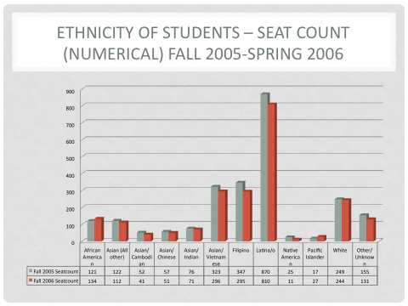

Figure 1. Mixed Data from the District Office Comparing Grouped Ethnicities vs.

Disaggregated Ethnic Groups: Seat Count (Numerical) 2005-2006

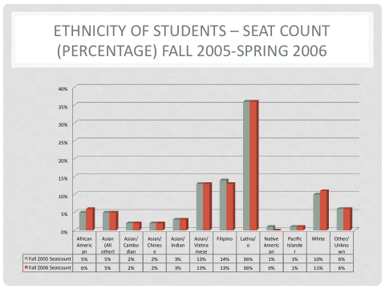

Figure 2. Mixed Data from the District Office Comparing Grouped Ethnicities vs.

Disaggregated Ethnic Groups: Seat Count (Percentage) 2005-2007

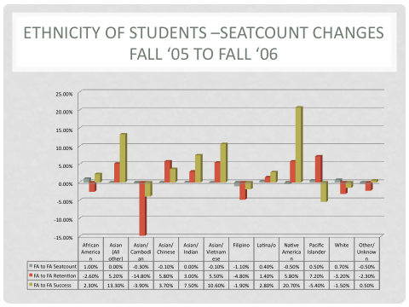

Figure 3. Mixed Data from the District Office Comparing Grouped Ethnicities vs.

Disaggregated Ethnic Groups: Seat Count (Changes) 2005-2006

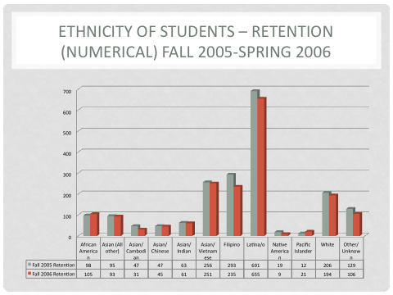

Figure 4. Mixed Data from the District Office Comparing Grouped Ethnicities vs.

Disaggregated Ethnic Groups: Retention (Numerical) 2005-2006

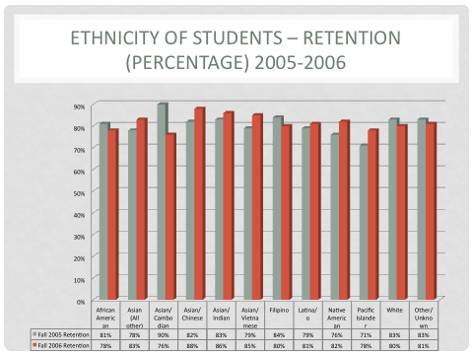

Figure 5. Mixed Data from the District Office Comparing Grouped Ethnicities vs.

Disaggregated Ethnic Groups: Retention (Percentage) 2005-2006

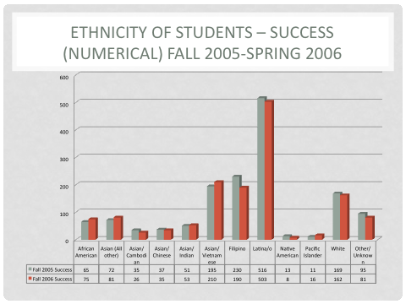

Figure 6. Mixed Data from the District Office Comparing Grouped Ethnicities vs.

Disaggregated Ethnic Groups: Success (Numerical) 2005-2006

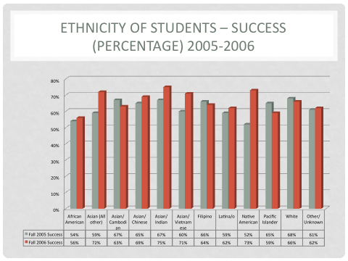

Figure 7. Mixed Data from the District Office Comparing Grouped Ethnicities vs.

Disaggregated Ethnic Groups: Success (Percentage) 2005-2006

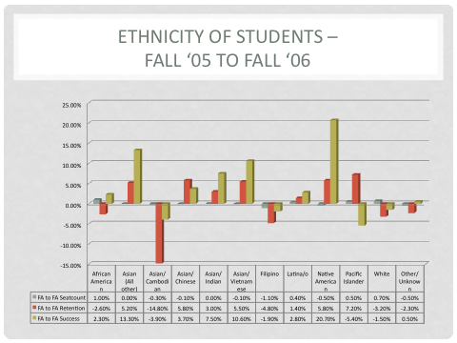

Figure 8. Mixed Data from the District Office Comparing Grouped Ethnicities vs.

Disaggregated Ethnic Groups: (Changes) Fall 2005-Fall 2006

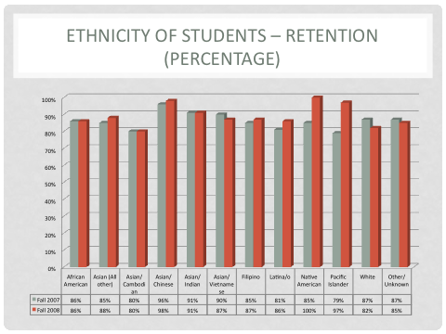

Figure 9. Mixed Data from the District Office Comparing Grouped Ethnicities vs.

Disaggregated Ethnic Groups: Retention (Percentage) Fall 2005-Fall 2006

**Appendix H: Mixed Data from the SJECCD District Office Comparing**

**Grouped Ethnicities vs. Disaggregated Ethnic Groups: 2007-2009**

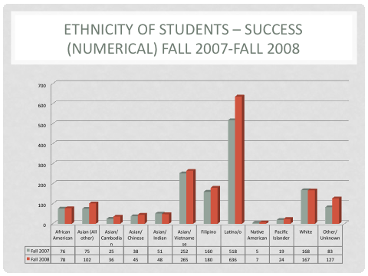

Figure 10. Mixed Data from the District Office Comparing Grouped Ethnicities vs.

Disaggregated Ethnic Groups: Success (Numerical Fall 2007-Fall 2008

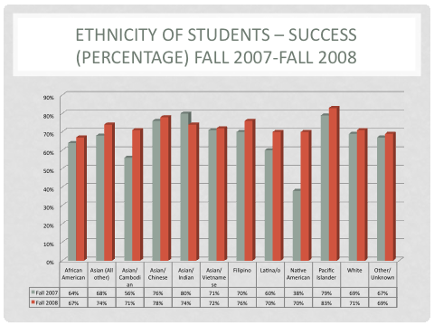

Figure 11. Mixed Data from the District Office Comparing Grouped Ethnicities vs.

Disaggregated Ethnic Groups: Success (Percentage) Fall 2007-Fall 2008

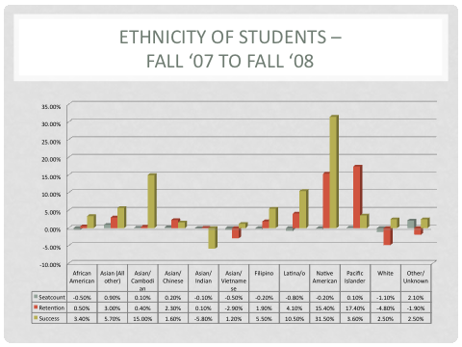

Figure 12. Mixed Data from the District Office Comparing Grouped Ethnicities vs.

Disaggregated Ethnic Groups: (Changes) Fall 2007-Fall 2008

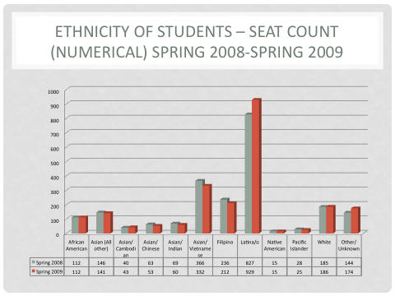

Figure 13. Mixed Data from the District Office Comparing Grouped Ethnicities vs.

Disaggregated Ethnic Groups: Seat Count (Numerical) Spring 2008-Spring 2009

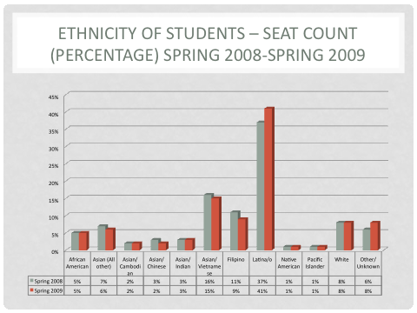

Figure 14. Mixed Data from the District Office Comparing Grouped Ethnicities vs.

Disaggregated Ethnic Groups: Seat Count (Percentage) Spring 2008-Spring 2009

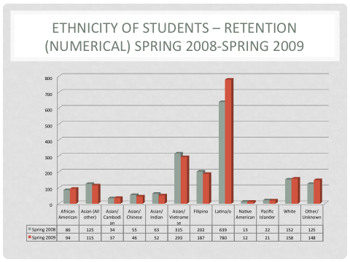

Figure 15. Mixed Data from the District Office Comparing Grouped Ethnicities vs.

Disaggregated Ethnic Groups: Retention (Numerical) Fall 2005-Fall 2006

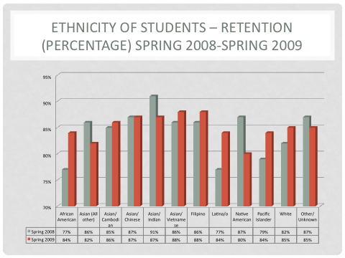

Figure 16. Mixed Data from the District Office Comparing Grouped Ethnicities vs.

Disaggregated Ethnic Groups: Retention (Percentage) Spring 2008-Spring 2009

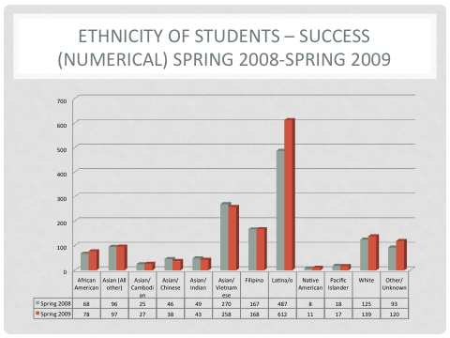

Figure 17. Mixed Data from the District Office Comparing Grouped Ethnicities vs.

Disaggregated Ethnic Groups: Success (Numerical) Spring 2008-Spring 2009

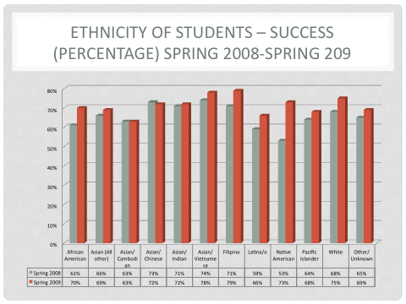

Figure 18. Mixed Data from the District Office Comparing Grouped Ethnicities vs.

Disaggregated Ethnic Groups: Success (Percentage) Spring 2008-Spring 2009

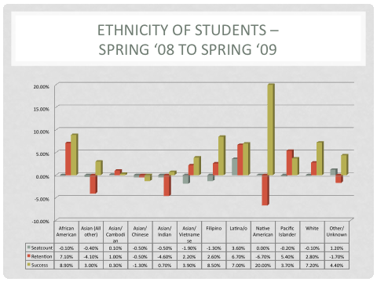

Figure 19. Mixed Data from the District Office Comparing Grouped Ethnicities vs.

Disaggregated Ethnic Groups: (Seat Count) Spring 2008-Spring 2009

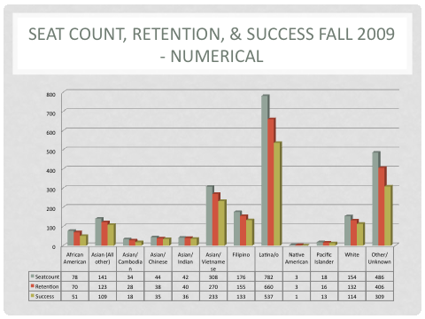

Figure 20. Mixed Data from the District Office Comparing Grouped Ethnicities vs.

Disaggregated Ethnic Groups: Retention & Success (Numerical) Fall 2009

**Appendix J: Aggregated Date Comparing Grouped Ethnicities:**

**2005-2007\***

**Appendix K: Aggregated Date Comparing Grouped Ethnicities:**

**2007-2009\***

**Appendix L: Aggregated Date Comparing Grouped Ethnicities:**

**2007-2009\***

**Note regarding Appendix J, K, and L: Charts, Graphs and Analysis Derived From Aggregated/Grouped Ethnicities, Will Be Added to the 2010/2011 English Program Review During the Summer 2011**

* Although some may not see additional graphs as necessary for the completion of Evergreen Valley College’s current English Program Review, such stats have become essential in order to contribute to the national conversation in the discipline. Here citing accurate facts and statistics and not confusing aggregated statistics with disaggregated statistics become essential.
* For data to be meaningful, we need to present facts, figures, and conclusions based on 1) aggregated group data, and 2) disaggregated data (e.g., data by gender or specific ethnicity as opposed to a group.
* When someone is confirmed as a permanent employee in charge of institutional research in the District Office, we will endeavor to work closely with him or her so that in the future, SanJose/Evergreen Valley College Stats will offer welcome, accurate information about our student body that can be used by the National Council of Teachers of English (NCTE), the Conference on College Composition and Communication (CCCCs), the English Council of California Two-Year Colleges (ECCTYC), The Young Rhetorician’s Conference (YRC), and the Two-Year College English Association (TYCA).