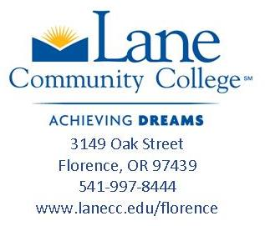

Meet LCC Florence Center’s Advisor

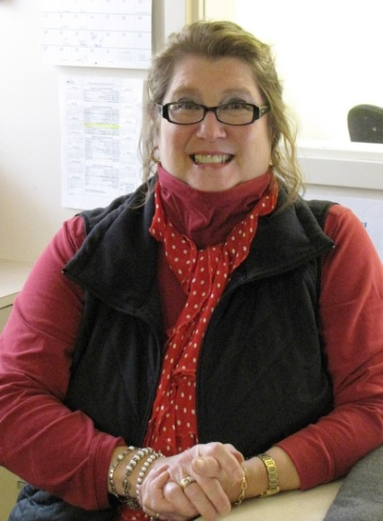
LCC Florence Advisor, Juanita Kirkham, has been with Lane since 1990, working first for the Welfare to Work (JOBS) program. For the past several years she has also helped coordinate the federal HOPE grant to retrain CNAs and healthcare workers through the Workforce Department in both Eugene and Florence. Currently, she works with DHS conducting job-search classes and on-the-job trainings in the community in addition to her work at the Florence Center.

Juanita has a Bachelor’s degree from the University of Wisconsin in Business Education, a Masters of Education from Oregon State and has recently completed coursework to attain a National Career Development Facilitator certification. She is on campus Tuesdays and Thursdays, so stop by the front desk or call to make an appointment to let her know how she can help!

