Disability Resources Faculty Updates ~Spring 2015

We Are Changing Our Name!
Disability Resources will soon have a new name: Center For Accessible Resources. This change reflects the evolving philosophy of our department as we move toward incorporating a universal design approach that will make Lane’s educational programs truly inclusive. We plan to work closely across departments to ensure that all students meet the same high standards.

Over the years, we have found the term “disability” to be limiting as it does not adequately capture the broad range of talents and experiences of our students. By shifting to “accessibility,” we are not only highlighting enhanced access to learning opportunities for all students, but also placing greater responsibility with the students themselves – to think through what they need and to self-advocate. Our goal is to equip students to access what they need to be successful, not only here at Lane, but also as they move out into the workplace.

Our hope in changing our name to Center for Accessible Resources is to raise what we have been doing to the next level: helping a diverse population of students become independent and resilient, while taking ownership and responsibility for their own education.

New Testing Center
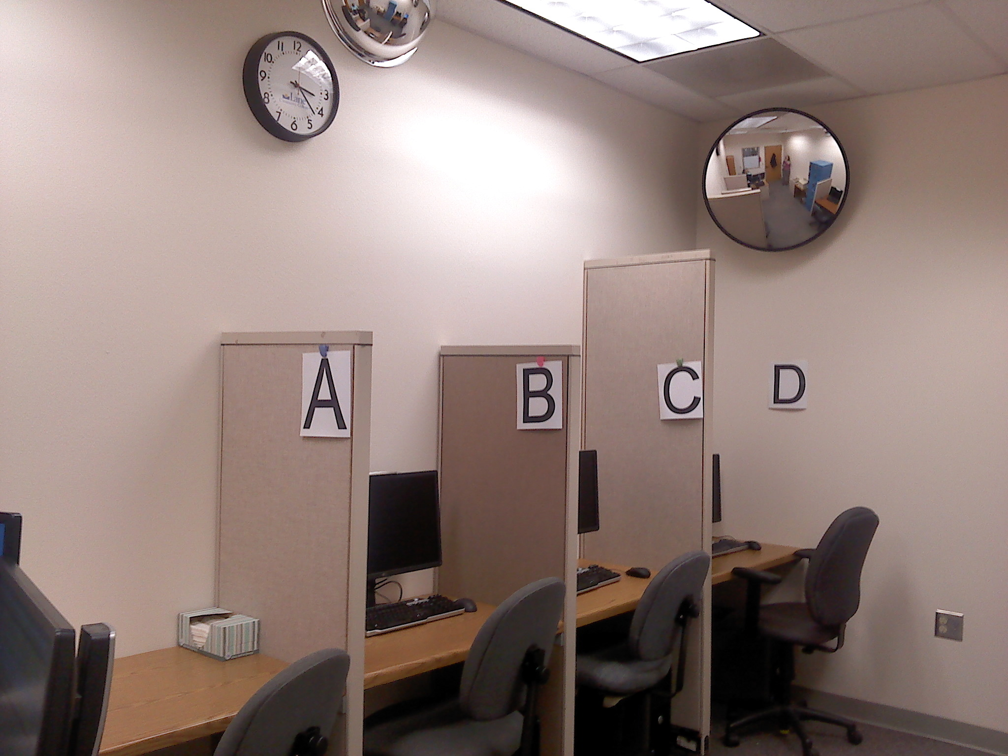
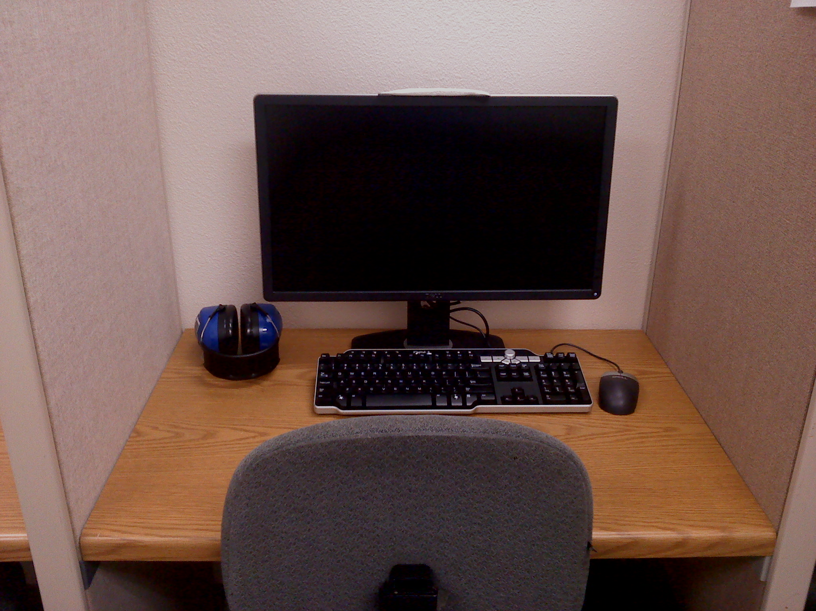
DR’s new testing center recently opened, with space to accommodate 6 students plus an additional room that can accommodate 4 students. Mirrors have been installed and lockers hold personal items, for secure test-taking. Our goal was to create a space for reduced distraction testing that is secure and utilizes universal design principles. Each partitioned area has a computer with accessible technology programs installed, such as screen-reader programs that convert text to audio. We also have equipment on hand that any student can request: magnification devices, ear plugs or headphones, the ability to listen to a Pandora station for music or white noise, and wheelchair accessibility. As a result, you will not see some of these accommodations listed as part of a student’s accommodations because they are available to any student who finds them helpful.

